Camp 143 - Carlton Hall, Carlton, Nottinghamshire

Included in the 1945 ICRC camp list – Labour Camp. 143. Carlton Hall, Carlton, Worksop, Notts.

Prisoner of War Camps (1939 – 1948) - Project report by Roger J.C. Thomas - English Heritage 2003
OS NGR | Sheet | No. | Name & Location | County | Cond’n | Type 1945 | Comments
SK 590 842 | 111 | 143 | Carlton Hall, Calton in Lindrick, Worksop | Nottinghamshire | 5 | German  Working Camp | Precise location not identified, NGR given for Hall, there is cropmark evidence for some structures at SK 5894 8433

Location: The NGR is for a location at the side of the A60 on the E edge of the estate, about where the ‘schs’ (Ramsden Primary School) is on the map. However, the school was there well before the war, it shows on an 1890 OS map.  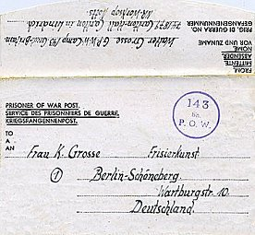  Before the camp: Country hall and estate.  Pow Camp:  < POW letter-sheet dated 16.6.1946  After the camp:  Further Information:  Link with C 143 Serlby Hall? | 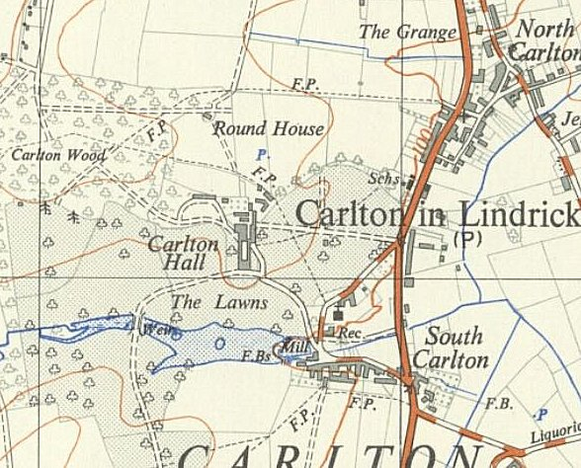
 | Ordnance Survey 1958

