Camp 142 - Brockworth Court, Brockworth, Gloucester, Gloucestershire

Included in the 1945 ICRC camp list – Labour Camp. 142. Brockworth Court, Brockworth, Gloucester.

Location: NGR for Brockworth Court is SO 891 171 – camp at SO 891 167. Another camp 554 Woodfield Farm is just 2.5 km N of here.  Before the camp:  Pow Camp: Italian Pows until at least 1945, then a German Working Camp.  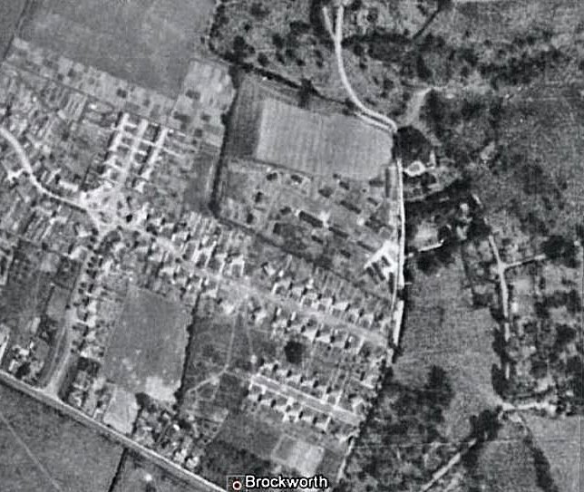  The huts can be seen in GE 1945 to the S of Brockworth Court (over the road from Parsonage Farm).  Hostel at Quedgeley Court - NGR SO 816 152. A large, late Victorian brick house, now demolished.  After the camp: 2019 residential area.  Further Information: | 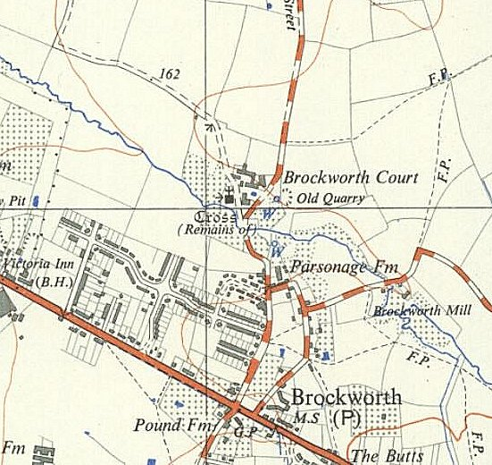
 | Ordnance Survey 1952

