Camp 141 - Beeson House Camp, St Neots, Huntingdonshire (Cambridgeshire)

Included in the 1945 ICRC camp list – Labour Camp. 141. Beeston House Camp, St.Neots, Huntingdonshire.

1947 Camp list
141(G.W.C.) | Beeson House Camp, St.Neots, Hunts. | E. | Priswar, St.Neots | St.Neots 184 | St.Neots | Lt.Col.F.W. Hargreaves | v/1453/2

Prisoner of War Camps (1939 – 1948) - Project report by Roger J.C. Thomas - English Heritage 2003
OS NGR | Sheet | No. | Name & Location | County | Cond’n | Type 1945 | Comments
TL 190 625 | 153 | 141 | Beeson House Camp, St Neots | Huntingdonshire  (Cambridgeshire) | 5 | German Working Camp | Precise location not identified, NGR given for Beeson Close, Little Paxton, St Neots

Location: There are conflicting references to the location.  An approximate position for the camp was given by a local history group – shown on the map. Although there is now a Beeson Close, I can find no reference or map details of Beeson House.  Another source states – “St Neots was the site of two prisoner of war camps. Beeson House and Wisteria House were both on Huntingdon Street. Beeson was the camp for Germans, Wisteria was provided for the Italians. Despite being prisoners of war, the locals and the prisoners - at least at some levels - were allowed to interact.” (Reported in the Hunts Post).  Before the camp:  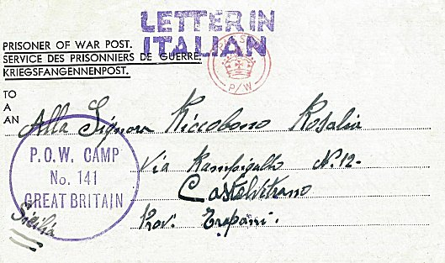  Pow Camp: Italian Pows until at least 1945, then a German Working Camp.  Camp commandant c.1947 Lieutenant Colonel F W Hargreaves  < 1945 Italian letter-sheet  After the camp:  Further Information:  London Metropolitan Archives – ‘Stapel, Chaplain Henning (POW Camp 141): Correspondence including material from his father Dr Wilhelm Stapel with detailed biographical accounts. Dated 1946 – 1947. Ref LMA/4288/A/04/117 | 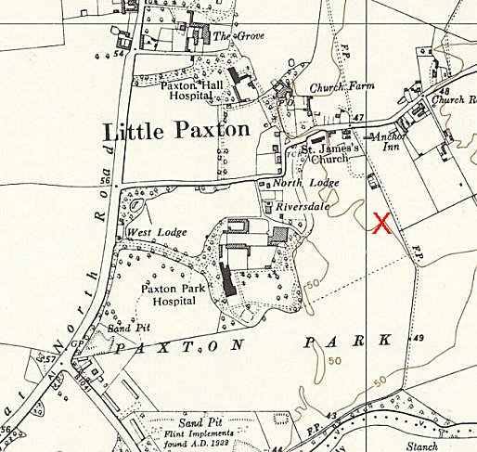
 | Ordnance Survey 1958

