Camp 137b - Winsford Towers Camp, Halwill, Beaworthy, Devon

Prisoner of War Camps (1939 – 1948) - Project report by Roger J.C. Thomas - English Heritage 2003
OS NGR | Sheet | No. | Name & Location | County | Cond’n | Type 1945 | Comments
SS 450 011 | 190 | 137b | Winsford Towers Camp, Halwill, Beaworthy | Devon | 5

Location: About 10 km SE of Holsworthy. I wondered if the camp may have been in Winsford Gardens and contacted the owner, who told me that; “Before the last owners of the walled gardens changed everything, there was a second world war Nissen hut surviving in the gardens.”  Before the camp:  Pow Camp: Most probably a sub-camp  Information received, (with thanks to Shawn, Holsworthy Museum historian):  “The camp at Winsford Towers was little more than a small satellite camp, under the control of Camp 42 (Exhibition Field Camp), Holsworthy.  The site of the camp had previously been occupied by a number of American Units, (mainly engineer and ammunition coys.) and was predominantly a tented camp. Becoming ‘vacant’ after June ’44, it was utilised as a small satellite camp.  Although I have not been able to confirm it, it seems probable that it was occupied only briefly, (probably not until Sep/Oct ’44 to early ’45 – after the arrival of the first German Prisoners at Camp 42. I don’t have my research to hand, but from memory, I seem to recall that it does not appear on an early 1945 list included in a report of a PP visit to Camp 42, although other satellite camps (Werrington, Boyton, etc) do.” | 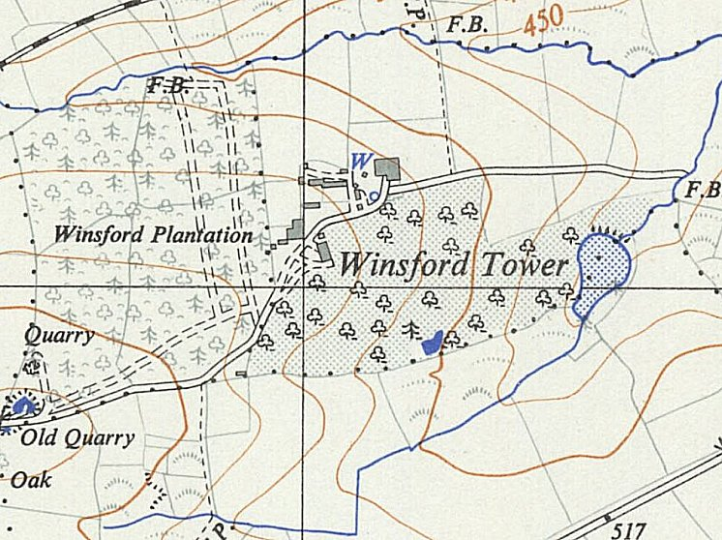
 | Ordnance Survey 1950
After the camp:

Further Information:

