Camp 137 - Hazeldene (Elburton) Camp, Elburton, Plymstock, Devon

Included in the 1945 ICRC camp list – Labour Camp. 137. Hazeldene Camp, Ellburton, Plymouth, Devon.

Prisoner of War Camps (1939 – 1948) - Project report by Roger J.C. Thomas - English Heritage 2003
OS NGR | Sheet | No. | Name & Location | County | Cond’n | Type 1945 | Comments
SX 53 52 | 201 | 137 | Hazeldene Camp, Elburton, Plymstock | Devon | 5 | German Working Camp

Location: ‘Hazeldene’, Elburton, is located at SX 535 540  Before the camp: Most likely a sub-camp.  Pow Camp:  After the camp: House demolished. Part of quarry.  Further Information: | 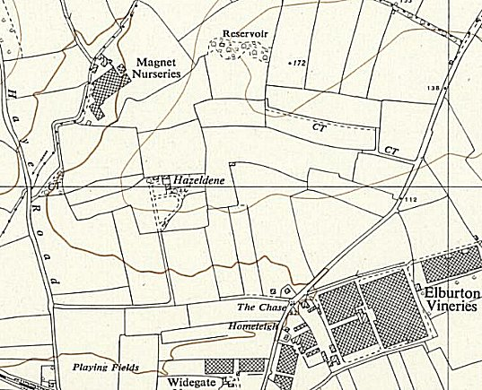
 | Ordnance Survey 1954

