Camp 137 - Chaddlewood House Camp, Plympton, Devon

1947 Camp list
137(G.W.C.) | Chaddleswood House, (Postal Address), Chaddleswood Camp, Plympton, Plymouth, Devon | S. | Priswar, Plympton | Plympton 2371 | Plympton (G.W.R.) | Lt.Col.E.A.Goodwin | v/1453/2

Prisoner of War Camps (1939 – 1948) - Project report by Roger J.C. Thomas - English Heritage 2003
OS NGR | Sheet | No. | Name & Location | County | Cond’n | Type 1945 | Comments
SX 55 56 | 202 | 137 | Chaddlewood Camp, Chaddlewood House, Plympton | Devon | 5

Location: SX 558 560 - small buildings on S of main house along driveway do not appear on the 1946 map.  Before the camp: Early 19th C country house and estate.  Pow Camp: Not known if Italian pows held here. A German working camp.  The German choir at the camp achieved some fame in local area and sang at various local venues. One regular place was Our Lady of Lourdes church in Plympton. When it was suggested the two choirs should combine, one member of the church choir stated, “If anyone objects because of past events, they have no right to be in God’s house.” (Further details of the choir in; ‘The Germans We Trusted’, Pamela Howe Taylor, 2003, Lutterowrth).  The Western Morning News reported that around 1000 invitations had been received by the camp commandant at Chaddlewood House, Plympton for pows to join local families for Christmas 1946.  There was a camp newspaper called “Nachtrichten Aus Aller Welt” (News from all over the World).  Last prisoners left 7 May 1948  Camp commandant c.1947 Lieutenant Colonel E A Goodwin  Postal items: POW letter-sheet 12 October 1947 in German to Berlin | 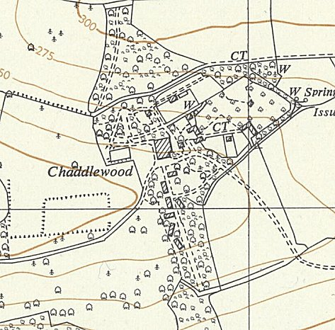
 | Ordnance Survey 1956
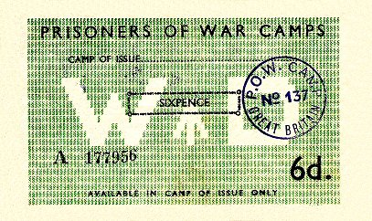
< Camp ‘money’ voucher for camp 137. There were various values. They could only be used in the camp as stamped. The voucher was stamped on the reverse after each use.

After the camp: Residential area.

Further Information:

IWM have a copy of the camp newspaper, dated May 1947 – ref LBY E.J. 396

