Camp 136a (& 264) - Welton House Camp, Brough, Yorkshire

1947 Camp list
136(G.W.C.) | Welton House, Welton, Nr.Brough, E.Yorks | N. | Priswar,Welton | Ferriby 296 | Brough | Lt.Col.F.N.Worthington M.M. | v/1453/2

Prisoner of War Camps (1939 – 1948) - Project report by Roger J.C. Thomas - English Heritage 2003
OS NGR | Sheet | No. | Name & Location | County | Cond’n | Type 1945 | Comments
SE 960 271 | 106 | 136a | Welton House, Welton, Brough | Yorkshire | 4 |  | Huts formerly sited woodland to east of house.  See Camp no. 136a / 264
 |  | 264 |  |  |  | German Working Camp

Location:  Before the camp:  Pow Camp:  A likely sub-camp was located at Bellasize, about 13 km from Welton House. Memories recorded by Herbert Heinemann on the BBC People’s War website –  “Bellasize Camp Nr 264. (Records show Camp 264 as Welton House, Welton, Brough.) [I think this should read as ‘sub-camp of Welton House]  Arriving [at] our new camp first of all we had to assemble, we were counted to be sure nobody [had] got lost. After that had taken place, we took possession of our huts. [It was the] First time I got the sight of a bed since 1944. Everybody of us was happy and surprised at the comfortable accommodation we were fond of. We felt like being in heaven. Commandant of this camp was a sergeant. A further two soldiers [were] in [the] charge of him and [we also had] the German camp leader. I was housed in hut 9. Again, we were ready to work on farms; some of us were busy in the sugar factory at Selby. They had a good job there. With another two of us I had to do different farm work. [The] Farmers name [was] Atkinson. We were supplied with Sandwiches, boiled eggs and tea, I thought I was dreaming in view of the food. Of course, we worked very hard for him to let him know we were very grateful. To my regret I went sick at a sudden and never saw him again. God bless him. [The] Distance to his farm from our camp [was] about 1.5 to 2 miles. At the 3lst of January, 73 of us had to leave Bellasize camp and left [the] likeable British soldiers behind. About 180 [of our group] were lucky to stay.” (Contributed by BBC Open Centre, Hull). | 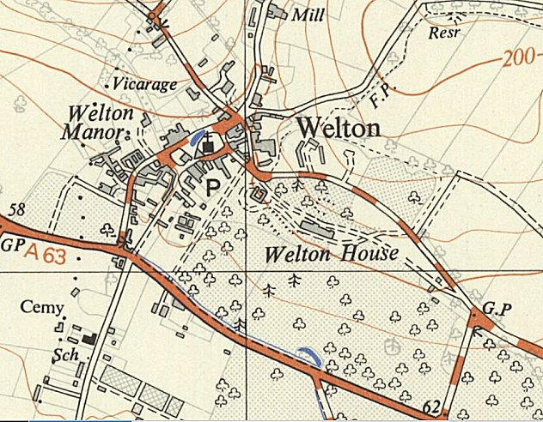
 | Ordnance Survey 1954

As well as the distance from the main camp. the fact that there was a sergeant in charge shows that this was a small camp without a commandant holding the rank of major or Lieutenant colonel. See map below.

Camp commandant c.1947 Lieutenant Colonel F N Worthington M.M. (I think he was with the Worcestershire Regiment).

After the camp: Welton House was demolished in 1952. 2019 residential area and St Anne’s Community Special School.

Further Information:

Bellasize farm shown on the 1953 Ordnance Survey map. NGR SE 826 278  To the left of the map is a possible site, just above where it says Pps with about 9 small buildings. This does not appear on the OS map published in 1946. | 