Camp 136 - High Hall Camp, Bishop Burton, Yorkshire

Included in the 1945 ICRC camp list – Labour Camp. 136. High Wall Camp, Bishop Burton, Beverley, Yorkshire.

Prisoner of War Camps (1939 – 1948) - Project report by Roger J.C. Thomas - English Heritage 2003
OS NGR | Sheet | No. | Name & Location | County | Cond’n | Type 1945 | Comments
SE 985 401 | 106 | 136 | High Hall Camp, Bishop Burton, Beverley | Yorkshire | 4 | German Working Camp | Site occupied by agriculture college

Location: About 5 km W of Beverley  Before the camp: Country estate  Pow Camp: Italian Pows until at least 1945, then a German Working Camp.  Memories – “There were two prisoner of war camps, one was just through the Westwood gates as you go to Walkington, but the big camp was where the agricultural college is at Bishop Burton.  The Italians went out to work on the land, then Italy surrendered and they were more or less dispersed on to farms and into factories.  Then the German prisoners of war came, and we used to go up to Bishop Burton college, or Bishop Burton Hall as it then was, the headquarters. In the grounds where the college is now were Nissen huts with prisoners in them. They used to go and work on the land, and various other places — woodyards and things like that and you used to see them going out under escort with maybe two soldiers with them. Then the war finished and so they relaxed the conditions for the German prisoners of war and some of them even married Beverley girls. There’s three or four stopped here all their life.” (From Sam Calvert - Contributed by East Riding Museums to BBC WW2 People’s War, 2005 – ID A7832973)  After the camp: East Riding County Council purchased High Hall with 422 a. in 1951, demolished the house and built an agricultural college on the site, now Bishop Burton College.  Further Information: | 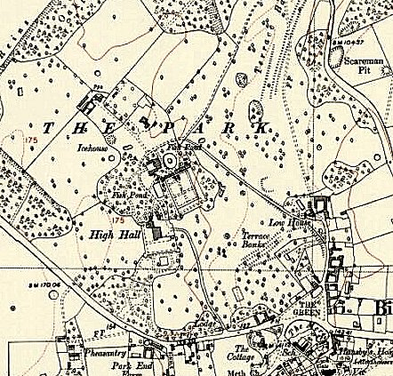
 | Ordnance Survey 1953

