Camp 135 - Stanbury House Camp, Spencer's Wood, Reading, Berkshire

Included in the 1945 ICRC camp list – Labour Camp. 135. Stanbury House Camp, Spencer’s Wood, Reading, Berks.

1947 Camp list
135(G.W.C.) | Stanbury House Camp, Spencer’s Wood, Reading, Berks | E. | Priswar, Spencer’s Wood | Spencer’s Wood 83158 | Reading | Lt.Col.W.Dickson M.C. | v/1453/2
Re-written > |  |  |  | Reading 83158

Prisoner of War Camps (1939 – 1948) - Project report by Roger J.C. Thomas - English Heritage 2003
OS NGR | Sheet | No. | Name & Location | County | Cond’n | Type 1945 | Comments
SU 712 670 | 175 | 135 | Stanbury House Camp, Stanbury Park, Spencers Wood, Reading | Berkshire | 3 | German Working Camp | Huts located under trees by the drive

Location: Site in Stanbury Park to the W of Spencer’s Wood.  Before the camp: Country estate.  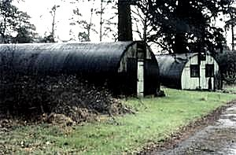  Pow Camp: Italian Pows until at least 1945, then a German Working Camp.  < The last 2 Nissen huts at Stanbury House Camp, 1964.  Memories state that the huts lined both sides of the long driveway beneath the large fir trees. (BBC war memories site).  The camp newspaper was called “Die Allee Stanbury House” (The Alley) – which seems to confirm the location of the huts.  Camp commandant c.1947 Lieutenant Colonel W Dickson M.C. | 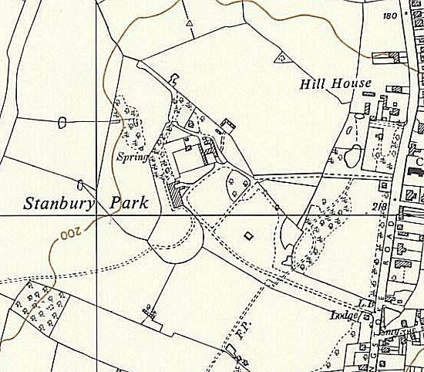
 | Ordnance Survey 1961

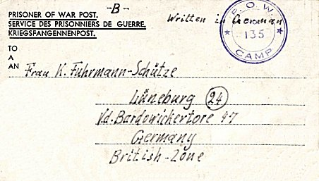
After the camp:
Further Information:

London Metropolitan Archives have a camp newspaper from 1947. Ref LMA/4288/D/04/007

< Letter-sheet November, 1946

