Camp 134 - Loxley Hall, Uttoxeter, Staffordshire

Included in the 1945 ICRC camp list – Labour Camp. 134. Loxley Hall Camp, Uttoxeter, Staffordshire.

Prisoner of War Camps (1939 – 1948) - Project report by Roger J.C. Thomas - English Heritage 2003
OS NGR | Sheet | No. | Name & Location | County | Cond’n | Type 1945 | Comments
SK 061 321 | 128 | 134 | Loxley Hall, Loxley, Uttoxeter | Staffordshire | 1 |  | Presently used as a school

Location: In the grounds of Loxley Hall.  Before the camp: Part of country house estate. Memories of US troops stationed here before it became a pow camp.  Pow Camp: Italian Pows until at least 1945, then a German Working Camp.  Memories of pows making baskets from willows growing on the bank of the River Blythe.  During questions about repatriation of German pows, an extremely sad account was raised in parliament:  “Mr. Molson asked the Chancellor of the Duchy of Lancaster whether he is aware that the wife of Paul Becker, a prisoner of war at Loxley, was injured in a street accident on 18th June, 1946, had both legs amputated and is still in hospital; that one of his children died of starvation in February, 1945; that there is another child aged seven years; and why this man, who has been a prisoner since 1st June, 1944, and is in political classification B, has not been granted compassionate repatriation.  Mr. J. Hynd - This prisoner of war is included in the first party of prisoners to be repatriated on compassionate grounds, and which will leave the United Kingdom on 28th February.” (House of Commons, 5 February 1947, Volume 432)  Postal items: POW Letter-sheet 6 March 1945 in Italian to Naples  After the camp: Site used to accommodate European Volunteer Workers, mainly from Eastern Europe. In 1954 the hall became a school. 2019 school and grounds.  Further Information: | 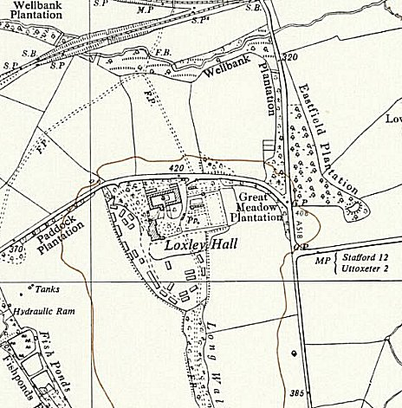
 | Ordnance Survey 1955

