Camp 133 - Hetton House Camp, Chatton, Alnwick, Northumberland

Included in the 1945 ICRC camp list – Labour Camp. 133. Hetton House Camp, Chatton, Alnwick, Northumberland.

Prisoner of War Camps (1939 – 1948) - Project report by Roger J.C. Thomas - English Heritage 2003
OS NGR | Sheet | No. | Name & Location | County | Cond’n | Type 1945 | Comments
NU 041 296 | 75 | 105 | Hetton House Camp, Chatton, Wooler | Northumberland | 4

Location: About 5 km NE of Wooler. Details state that the camp was opposite Hetton House.  Before the camp:  Pow Camp:  Later became sub-camp to 105 Wooler and listed under that number in the English Heritage Report.  Postal items: POW Letter-sheet 6 March 1945 in Italian to Naples  After the camp: 2019 house / woodland / farmland. Hetton House is listed as; “retail sale of books in specialised stores”.  Further Information: | 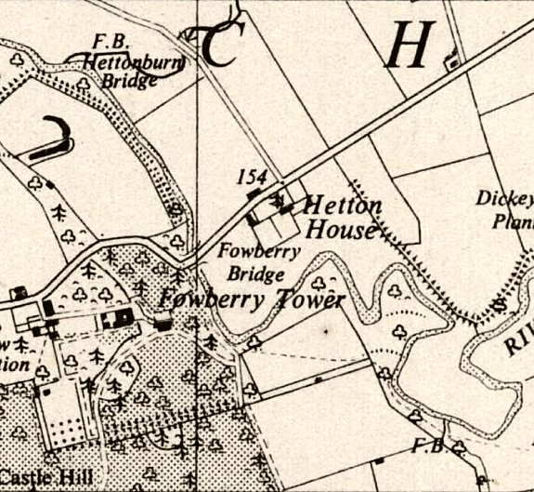
 | Ordnance Survey 1950

