Camp 132 - Kimberley Park, Kimberley, Norfolk

Included in the 1945 ICRC camp list – Labour Camp. 132. Kimberley Park Camp, Wymondham, Norfolk.

Prisoner of War Camps (1939 – 1948) - Project report by Roger J.C. Thomas - English Heritage 2003
OS NGR | Sheet | No. | Name & Location | County | Cond’n | Type 1945 | Comments
TG 0935 0479 | 144 | 132 | Kimberley Park, Kimberley | Norfolk | 4 |  | Huts located under trees by the drive

Location: About 4 km NW of Wymondham  Before the camp: Parkland attached to Kimberley Hall.  Pow Camp: Italian Pows until at least 1945, then a German Working Camp.  “All the features lie within the eastern portion of Kimberley Park with the centre of the pow camp at TG 0938 0483.  The camp, sited under trees along the drive approaching Kimberley House, comprised various huts, gardens and sports fields, presumably for the use of the prisoners as well as the guards… [aerial] photographs suggest that it was certainly still in use in 1946. The huts, gardens and playing fields appear to extend westwards along the drive as far as Kimberley House itself. They include a formal garden (at TG 0940 0485)… a football pitch and a tennis court.” (Extracted details from heritage.Norfolk, by S. Tremlett, 14 March 2012).  Incidental information from a German theatre group journal held by the Deutsches Historisches Museum. The group toured pow camps around England during 1946. It recorded its visit to Kimberley Park Camp, 253[sic] in late 1946.  Postal items: POW Letter-sheet 16 September 1945 in Italian to Italy  After the camp: Woodland. | 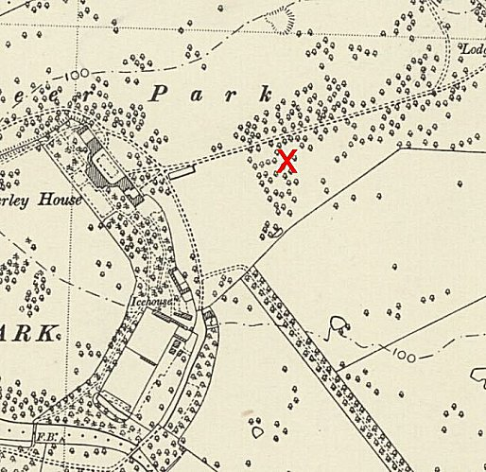
 | Ordnance Survey 1953
Further Information:
Aerial photographs by RAF 1946 – RAF 3G/TUD/UK/52 5240-2 31-JAN-1946, and RAF 106G/UK/1429 3128-30 16-APR-1946.

