Camp 127 (& 296) - Potter's Hill, High Green, Sheffield, Yorkshire (+ Ravenfield)

Included in the 1945 ICRC camp list – Labour Camp. 127. Potters Hill Camp, High Green, Sheffield.

1947 Camp list
296(G.W.C.) | Potters Hill Camp, High Green, Sheffield | N. | Priswar, High Green | High Green 77 | (Blank) | Lt.Col. W.J.Arnold | v/1453/2

Prisoner of War Camps (1939 – 1948) - Project report by Roger J.C. Thomas - English Heritage 2003
OS NGR | Sheet | No. | Name & Location | County | Cond’n | Type 1945 | Comments
SK 33 97 | 111 | 127 | Potter's Hill, High Green, Sheffield | Yorkshire | 5 | German Working Camp | See Camp no.296

Location: The above NGR is a general location. The camp was located at SK 334 970.  Before the camp: In 1936, fields.  Pow Camp: Listed as Italian working camp / labour battalion to at least late 1945, then a German Working Camp.  The camp was inspected on 14 November 1945 by the International Red Cross, report below.  Various memories of the camp (https://www.sheffieldforum.co.uk/) –  “I was told by the older locals that the camp was used to billet American soldiers prior to D Day, and then used as a prison camp for Italian prisoners.”  “I had heard that the Italians painted the inside of St Mary’s Church [just off the map NE corner] and that when the Americans were there they used to go training in Westwood.”  “One of the Italian pow's jobs was concreting the roads that were to become the (New) Parson Cross estate - the part that is near Ecclesfield -“  “There were German prisoners there for a short while, until 3 of them did a runner, they were caught about a mile down the road by a local bobby.”  Sub-camps / Hostels:  High Melton (Possible site just N of High Melton on Sheep Lane, next to Melton Wood)  Thrybergh – see Ravenfield below.  Woolley  Hoyland  Barnsley Road, Doncaster | 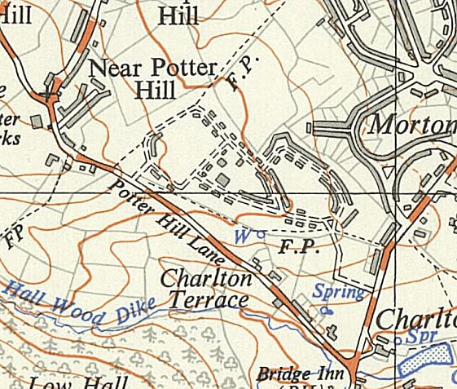
 | Ordnance Survey 1951

Camp commandant c.1945 Major R Coolhurst (unable to trace this name).
Camp commandant c.1947 Lieutenant Colonel W J Arnold, from the East Lancashire Regiment.

After the camp: “Some camp structures & facilities were used after the wars end for public housing. By the early 1960's this was no longer the case and all that remained were concrete roads and some foundations. Traces of the camp have been completely eradicated by more recent development that started in the late 1960's” 2019 residential area.

Further Information:  National Archives  - - - -  Entries for Potter’s Hill often mention Bracken Hill Camp, but they were separate sites.  “Bracken Hill and Potter Hill are two different camps. B/H is at Burncross, P/H is at High Green. The roads round B/H are Chapel Rd, Burncross Rd and Bracken Hill, and Spring Wood on the other side. To get to P/H go down Charlton Brook, then up Potter Hill Lane, that is the nearest side to B/H.” This message is confirmed by several others about there being two camps.  This site is only a mile or so from Potter’s Hill NGR SK 354 956. The site is now a school playing field. |  | 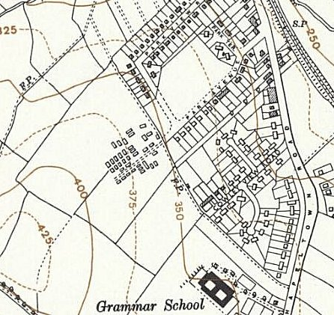
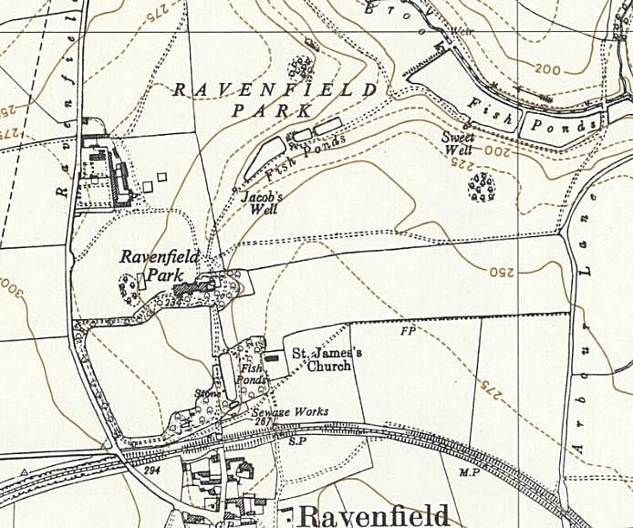 | Ordnance Survey 1956 >  - - - -
Ravenfield Park Camp, Rotherham, Yorkshire – Sub-camp for Potter’s Hill

Prisoner of War Camps (1939 – 1948) - Project report by Roger J.C. Thomas - English Heritage 2003
OS NGR | Sheet | No. | Name & Location | County | Cond’n | Type 1945 | Comments
SK 4847 9550 | 111 | 296 | Ravensfield Park Camp, Rotherham | Yorkshire | 4 |  | Farmland

Listed as Thryberg, the nearby village, in the ICRC inspection report below. Ravenfield Hall was located at SK 483 955

The camp was in Ravenfield Park, near to the fish ponds. Guard officers used Ravenfield Hall.

There was a camp newspaper – Die Fahre (The Ferry). Issued fortnightly. The IWM have a copy from February 1948. Ref LBY EJ 353

NOTE late date for this camp still being open into 1948.
Ordnance Survey 1956

Postal item: POW Postcard 28 June 1948 in German to Berlin.

Working Battalion 127 (Italians)  Visited on 14 November 1945 by M. de Watteville  Camp Address: Italian Labour Camp 127  Commandant: Major R Coolhurst & Adj. Lieutenant Slack  Camp Leaders:  Potters Hill de MARO M. “Marescallo” No 175897  TOMMASINI F. “SM” 497831  High Melton NICOLODI Eligio, “Maresc.” 240949  BRIGANTE Antonio, “S/Mj.” 81788  Thrybergh NEGRO Giuseppe, “Maresc.” 495584  TEDESCO Michele, “S/Mj.” 49809  Woolley RAGO Fedele, “S/Mj.” 209660  SPOSITO Luigi, “Sjt.” 209665  Hoyland BARROI Mario, “S/Mj.” 122522  DI MAURO Rocco, “Sjt.” 118912  Barnsley Rd. Camp TIOLI Eliodoro, “S/Mj.” 497822  Doncaster TROIANO Ciro, “Sjt.” 285559  Italian Officers: BARSARELLI Tenente, chaplain 26050  MONDELLA Tenente, doctor 209065  Capacity: About 2000 men  Strength: 1145 Italian prisoners distributed in the following way:  Potters Hill 392  High Melton 240  Barnsley Road, Doncaster 74  Hoyland 71  Wooley 80  Thryberg 222  Living in local houses 55  In hospital 11  Prisoners working for the “Ministry of Supplies” 251  and the “Ministry of “War” 336  in agriculture 224  transportation 32  off work 3  ill 81  in transit 110  permanently with the camp 108 |  | The 240 prisoners of High Melton are warrant officers (sergeants and sergeants-major) who asked to work. This camp is also used as a repatriation centre (3000 prisoners of this category have passed through).  General  This camp, built at the beginning of the war by the municipality of Sheffield to place local people in case of air raids, is located on a hill ten kilometres from Sheffield.  The buildings are made of bricks and the kitchens and the refectories are very well arranged (steam, electricity, refrigerator, etc.) A large hut is used as a chapel or movie theatre.  Each of the 44 barracks contain 6 rooms, as well as W.C. and toilets.  For the prisoners who remain in the camp there are 9 beds per room, and for the prisoners in transit, 6. All areas are lit with electricity and are heated by small stoves. Fire-fighting equipment is in place. Bed linen is excellent and the prisoners have 8 bathtubs and showers, with hot water four times per week.  Food  No complaints were presented about food and up until now the reduction in rations has not had an unfavourable effect. Three meals are served per day. Men who work away from the camp take a packed lunch.  Menu for 14 November 1945:  Breakfast: milk, marmalade, bread  Lunch: tea, milk, and in camp; meat and potatoes.  For workers: sandwiches  Dinner: Pastes, peas, sausages and roast potatoes.  Medical care  The infirmary, very well managed at Potters Hill, is under the direction of the Italian lieutenant doctor who also visits the “hostel” at Thrylberg three times per week. The five other “hostels” are entrusted to local English doctors. The doctor lieutenant MONDELLA also works as dentist in a very well-equipped dentist’s surgery. He is assisted by 4 medical members of staff. The infirmary has 13 beds for patients, two isolation rooms and all the necessary buildings (two bathrooms, etc.).  The doctors state that health and nutrition is good. The relatively large number of patients of battalion 81 is explained by the fact that they are mainly prisoners being repatriated for health reasons and who are passing through the camp. Five to six patients are present at the daily medical visit. A medical examination takes place each month.

On November 14 1945, the following 5 cases were having treatment at the hospital;  strained foot  gastric  knee wounded by accident  problem with circulation  psychopathic.  There were no cases of epidemic or serious illness. A man committed suicide (by hanging) the day before being repatriated because he had received bad news from home. Twenty-seven prisoners, often sick, were declared suited for light work (office, etc.) by British doctors. Like all prisoners, the medical personnel are free in the evenings.  Clothing  The prisoners are very well dressed in clothing which is in good condition, the same for their shoes. They arrange their own cleaning, having sufficient hot water and soap.  Work and pay  Prisoners that work around the camp earn 9 to 10/- each week and can send to money to their families, but that takes a long time. They are transported to their work place, leaving the camp at 0700, to return at 1700. After dinner they are free until 2200.  Canteen  The prisoners have a canteen and in spite of the lack of goods and low prices, the “Welfare Fund” exceeds the £250 planned for a camp of this size. Each prisoner is given 35 cigarettes per week and can buy another 5.  Religious services  The chaplain rarely visits the different “hostels”. He regularly holds mass in the camp and exerts a good influence amongst the prisoners.  Leisure  The prisoners have a football field and footballs. They have also playing cards, jeux de dames, chess, etc. The library has approximately 250 volumes, but it does not seem possible to organise lessons. On the other hand, film shows take place twice per month (today, for the first time, an Italian film). |  | Correspondence  This works perfectly well. By paying 5d, the prisoners can send their letters by airmail.  Conclusion  Excellent camp in all respects. The head of camp and the 2 Italian officers did not have any complaints to raise.  (Translated by M Sanders 2010)

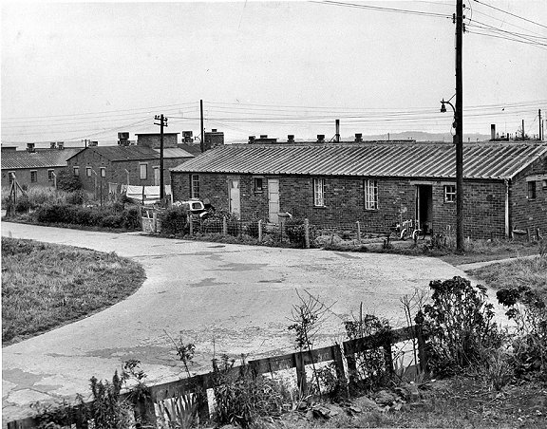 |  | 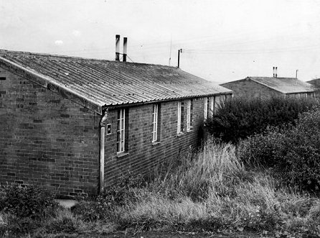

Pictures taken 21/09/1964 - Images used with the kind permission of Sheffield Newspapers Ltd – Ref Nos s25595 / s25596

