Camp 124 / 124a - Bedminster Camp, (Ashton Gate Camp), Ashton Gate, Bristol, Gloucestershire

Included in the 1945 ICRC camp list – Labour Camp. 124. Bedminster Camp, Ashton Gate, Bristol.

1947 Camp list
124(G.W.C.) | Bedminster Camp, Ashton Gate, Bristol 3. | S. | Priswar, Bristol | Bristol 64700 and 64471 | Bristol | Lt.Col.A.J.Uden | v/1453/2

Prisoner of War Camps (1939 – 1948) - Project report by Roger J.C. Thomas - English Heritage 2003
OS NGR | Sheet | No. | Name & Location | County | Cond’n | Type 1945 | Comments
ST 58 71 | 172 | 124 /a | Ashtongate Camp / Bedminster Camp, Ashton Gate, Bristol | Gloucestershire (Avon) | 5 | German Working Camp

Location: NGR above is a general location.  Before the camp:  Pow Camp: Italian pows, then a German working camp.  There was a link between this camp and Camp 6A at nearby Ashton Court.  Camp commandant c.1947 Lieutenant Colonel A J Uden, from the Royal Regiment of Artillery.  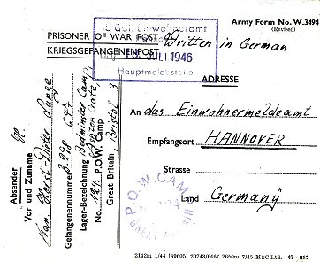  Postal items: 1944 letter-sheet in Italian.  < Postcard July 1946 to Germany.  After the camp:  Further Information: | 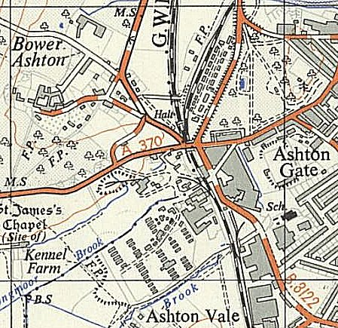
 | Ordnance Survey 1951

