Camp 122 (& 274) - Ministry of Works Camp, (Oxhey Lane Camp), Hatch End, Middlesex

1947 Camp List
122(G.W.C.) | Rayners Lane Camp, Rayners Lane, Harrow, Middlesex | L.D. | Priswar, Harrow | Byron 4471 | Harrow Wealdstone (L.M.S.) Northolt G.W.R. Rayners Lane (Met and Picc Lines) | Lt.Col.G.F.Tillman | v/1453/2
The entry above has been crossed out in blue crayon and the following details handwritten on.
 | Oxhey Lane Camp, Uxbridge Road, Hatch End, Middx |  | Hatch End | Hatch End 1387 | Hatch End (L.M.S.) & Bakerloo | Lt.Col.H.N.Drake

Prisoner of War Camps (1939 – 1948) - Project report by Roger J.C. Thomas - English Heritage 2003
OS NGR | Sheet | No. | Name & Location | County | Cond’n | Type 1945 | Comments
TQ 142 916 | 176 | 122 | Oxhey Lane Camp, Uxbridge Road, Hatch End | Middlesex | 4 | German Working Camp | STANDARD type. Site occupied by a sports centre
 |  | 274

Location: N edge of Harrow.  Before the camp: Farmland  Pow Camp: From the lists it seems that this was at first Camp 274, and then as Rayners Lane closed, it was allocated that camp’s number. (Why?)  Italian Pows until at least 1945, then a German Working Camp.  The site had a standard layout with a main pow compound, with guards’ huts and offices at the front. Common buildings and facilities at standard type camps included water towers, offices, officer's mess, a canteen, guard rooms, barrack huts, ablution blocks, cell blocks, a camp reception station (medical facility/hospital), a cookhouse, dining rooms, recreation rooms and living huts or tents.  In 1944 as Italian pows were increasingly placed in billets and hostels, a question arose in Parliament:  “Sir R. Blair asked the Parliamentary Secretary to the Ministry of Works how many former Italian prisoners of war are being accommodated in houses in the ​ residential neighbourhood of Pinner and Hatch End; will he state the nature of their work; and how long are they expected to stay in view of the acute shortage of housing accommodation both for the families of Service men and others from the bombed areas.  Mr. Hicks Italian prisoners-of-war, on the application of Government Departments, have been allocated by the Ministry of Labour for essential work some of which is in the London area. This includes railways, food distribution and public utilities. In order to comply with the requirements of the Geneva Convention prisoners-of-war, at this time of the year, are moved out of tented accommodation and the War Office have released, in substitution for tents, accommodation including houses already under their requisition… The numbers accommodated in Pinner and Hatch End are 1,146, and they are employed on essential work. The question | 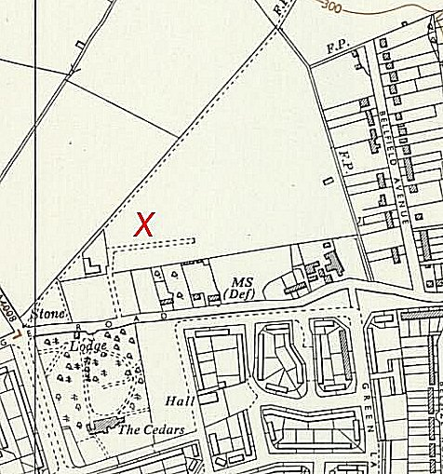
 | Ordnance Survey
whether it will now be possible to dispense in whole or in part with the use of this labour in London is at present being considered by the responsible departments.” (House of Commons, 4 October 1944, Volume 403).

Camp commandant c.1947 Lieutenant Colonel Henry Norman Drake from the Northamptonshire Regiment.

After the camp: 2019 sports centre and running track.

Further Information:

National Archives FO 939/308 – 122 Working Camp, Hatch End Camp, Harrow, Middlesex. Dated 1946-1947

