Camp 121 - Racecourse Camp, Ripon, Yorkshire

Included in the 1945 ICRC camp list – Labour Camp. 121. Racecourse Camp, Ripon, Yorkshire.

Prisoner of War Camps (1939 – 1948) - Project report by Roger J.C. Thomas - English Heritage 2003
OS NGR | Sheet | No. | Name & Location | County | Cond’n | Type 1945 | Comments
SE 328 470 | 99 | 121 | Racecourse Camp, Ripon | Yorkshire | 4 | German Working Camp

Location: The NGR above is incorrect. Ripon Racecourse is SE 329 699. Just to the SE of Ripon  Before the camp: Racing on the present site on Boroughbridge Road began on 6 August 1900.  Pow Camp: Italian pows, then a German Working Camp.  “In August 1946, 27 year old Hans Kupzong, a POW held at Ripon camp, was brought before a court martial. Evidence was provided including letters which had passed between Kupzog and a local girl named Thirkill. It was stated that on one occasion they had met in a wood near Wath where they kissed and marriage was mentioned. Thirkill stated in court that cycling to work with a friend, Kupzog had waved to them and they had waved back. In May 1945 six letters were exchanged between them; Thirkill passing them to Kupzog on her way to and from work. Kupzog had also made her a wallet, and she in return gave him chocolate and cigarettes. Her friend, Aileen White, also 17 years old, admitted to passing letters and the wallet between Thirkill and Kupzog. Thirkill denied that she had encouraged him; rather she was sympathetic to his plight as a POW. Kupzog, pleading not guilty, maintained that he misunderstood the meaning of the term fraternisation. However, the German camp leader stated that the regulations had been made well known in the camp. Kupzog argued that he had only heard of the regulations when he had been charged; he believed that talking and writing to British women was permitted. The solicitor defending Kupzog agreed that as a victorious nation, Britain had to ensure the discipline of German POWs was maintained. However, he argued that the regulations had not been given or had been given in a manner which Kupzog had misunderstood. 'We have to protect our womenfolk', the solicitor stated, 'but there is a certain type of woman who will go after and encourage people who a short time ago were our enemies. I think that from a humane point of view this is grossly unfair to the prisoner concerned'. Kupzog was charged with conduct prejudicial to good order and discipline in that between 30 April and 26 May he had improperly associated with Thirkill. Such incidents continued into 1947.” (Original story: ‘German P.O.W. Charged with Fraternisation: Kissed Yorkshire Girl in Woods, Marriage Mentioned’, Yorkshire Post, | 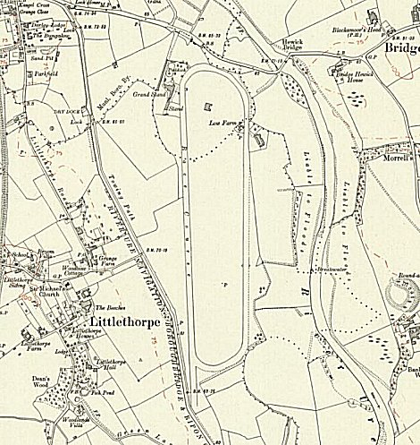
 | Ordnance Survey 1930
18 August 1946. Detailed in ‘British Attitudes towards German prisoners of war and their treatment: 1939-48 – Alan Patrick Malpass – 2016 – Sheffield Hallam Unversity).
The camp closed during 1946, (the Great St Wilfred race was held in August 1946). The camp number was re-allocated to Scriven Camp.

After the camp: 2019 racecourse.

Further Information:

