Camp 120 - Sunlaws Camp, Kelso, Roxburghshire

Included in the 1945 ICRC camp list – Labour Camp. 120. Sunlaws Camp, Kelso, Roxburghshire.

1947 Camp list
120(G.W.C.) | Sunlaws Camp, Kelso, Roxburghshire | Sc. | Priswar, Kelso | Roxburgh 208 | Kelso | Lt.Col.J.H.C.Lawlor | v/1453/2

Prisoner of War Camps (1939 – 1948) - Project report by Roger J.C. Thomas - English Heritage 2003
OS NGR | Sheet | No. | Name & Location | County | Cond’n | Type 1945 | Comments
 |  | 120 | Sunlaws Camp, Kelso | Roxburghshire |  | German Working Camp | Scotland

Location: NGR NT 703 297  Before the camp: Private country estate.  Pow Camp: Listed as an Italian working camp / labour battalion to at least 1945, then a German Working camp.  “The house was requisitioned by the Army just after the outbreak of war in 1939. Uncle Bob was left the Drawing Room, the flat on the ground floor and the Queen's and Chintz rooms next door to each other on the first floor, the military taking the rest. They used the house as the headquarters of the prisoner of war administration for the counties of Roxburgh, Berwick and Selkirk. There was a Commanding Officer with a second in command living in the house, plus a quantity of German prisoners of war. Previously there had been Poles and Italian prisoners at Sunlaws. The house was finally de-requisitioned in 1948.” (From a history of Sunlaws written by Robert Scott-Kerr).  Unusually, the house was used to hold pows, not sure if the grounds were as well.  “Horst Hassold, 87, was held at Sunlaws House - now the Roxburghe Hotel - near Kelso in 1945. The former gunner in the German navy said he had always been grateful for the way he was treated in Scotland. He returned to the Borders to visit the attic room where he slept. It is now used as a store room, but still has the prisoners' names on the door.  Mr Hassold was moved around camps across Britain before ending up in the south of Scotland. In December 1945 he was billeted in Sunlaws House. Because he had studied English for two years at school he worked as an interpreter and did the accounts for the canteen.” (BBC News 9 July 2013). | 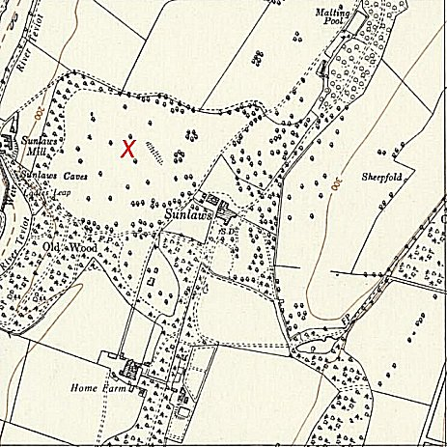
 | Ordnance Survey 1957

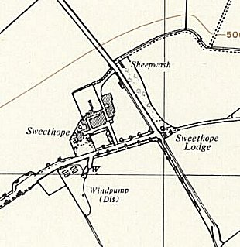 | Hostels for the camp:  1 Greenlaw  2. Lauder  3. Earlston  4. Duns  5. Sweethope - probably Sweethope farm / lodge NT 688 391.  6. Chirnside - possible site to left of map NT 865 564.  7. Reston - possible site to right of map NT 885 621.  8. Greenriggs – Greenriggs farm is just to the S of Wester Howlaws at NT 723 422.  9. The Hirsel – NT 829 407  10. Melrose  11. Selkirk – “There were also Italian prisoners of War, they were stationed in what is now Bannerfield” (BBC People’s War.) Bannerfiled is on the NW edge of Selkirk NT 460 291.  12. Sligh Houses – NT 822 594
Sweethope - 1958 Ordnance Survey
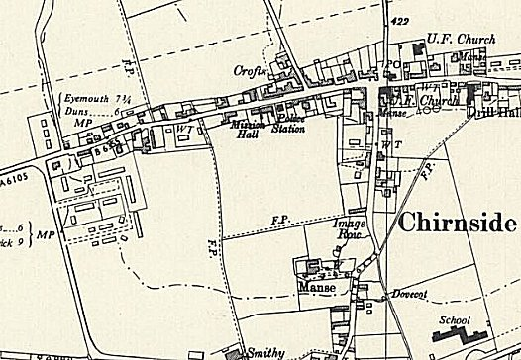 | 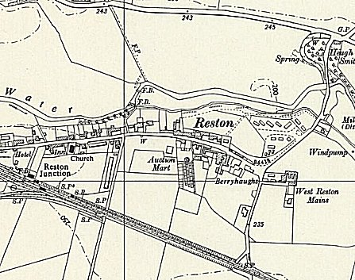 | Camp commandant c.1947 Lieutenant Colonel J H C Lawlor, from the Duke of Wellington’s Regiment.  Postal items: POW Letter-sheets 29 November 1943 and 29 November 1945 written in Italian to Italy.  After the camp: For a while the house went back to private ownership. 2019 the site marked is a golf course; Sunlaws House is now called Roxburghe Hotel.  Further Information:
Chirnside – 1957 Ordnance Survey | Reston – 1957 Ordnance Survey

