Camp 117 - Walderslade Camp, King George Street, Chatham, Kent

Included in the 1945 ICRC camp list – Labour Camp. 117. Walderslade Camp, King George St, Walderslade, Chatham, Kent.

1947 Camp list
117(G.W.C.) | Walderslade Camp, King George St., Walderslade, Chatham, Kent | E. | Priswar, Chatham | Bluebell Hill 324-5 | (Blank) | Lt.Col.P.Goldsmith, M.B.E. M.C. | v/1453/2

Prisoner of War Camps (1939 – 1948) - Project report by Roger J.C. Thomas - English Heritage 2003
OS NGR | Sheet | No. | Name & Location | County | Cond’n | Type 1945 | Comments
TQ 757 643 | 178 | 117 | Walderslade Camp, King George Street, Chatham | Kent | 4 | German Working Camp

Location: On a field opposite the Poacher’s Pocket public house – formerly called the Hook and Hatchet.  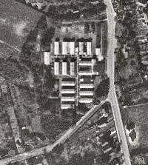  Before the camp: Farmland  Pow Camp: Not certain if Italian pows were held here.  Newspaper article 1946 – “Admitting that they had spent the greater part of the night in the woods with two escaped German prisoners, two girls, aged 14 and 15, pleaded guilty at Chatham Juvenile Court today to having acted in a way likely to prejudice discipline of prisoners of war.  Detective-Inspector E.G.Everett stated that when the men were reported missing from Walderslade camp, a search was organised which continued most of the night. The girls, who had also been reported missing, were seen at 4.30 a.m., coming home through the woods. When questioned they said, “We have been with two prisoners in a hut.”  Asked by the Chairman (Mrs.H.E.Mitchell) why they went with the Germans, one of the girls replied, “We did it because we liked them.”  Mrs.Mitchell: “Are you not disgusted with yourselves?”  “No.” replied the girls  Putting the girls on probation for three years, the Chairman commented, “This was a disgraceful thing to have done. However well behaved the prisoners are, it is a great temptation to them to have girls such as you hanging about the camp.” (Original story from the Lancashire Evening Post; reported on kenthistoryforum.co.uk). | 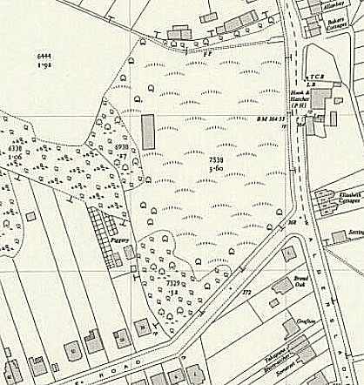
 | Ordnance Survey 1955

This story fits into a wider picture of changing relationships between civilians and pows at this time – “That Christmas of 1946 brought a dramatic breakthrough of human feeling. All over the country invitations poured into the camps…. The villagers at Walderslade near Chatham had earlier protested at the building of a camp for German POWs, and

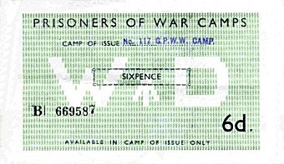 | 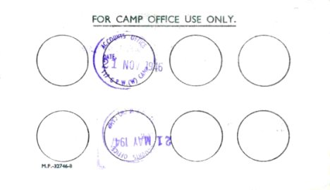 | later had tried without success to have the names of girls published who – illegally of course – had fraternised. Now they sent over two hundred invitations up to camp.” (Thresholds of Peace, p 187 – Matthew Barry Sullivan – 1979 – Hamish Hamilton).  The local Salvation Army band visited the camp on three occasions during 1946 – one comment; “A programme of music and song suitable for the occasion was rendered and well appreciated by crowd that packed the hall to overflowing. The singing of the prisoners was grand, especially the carol “Stille Nacht” sung in German.”
Camp ‘token money’ issued by the War Department – various values were used. They could only be exchanged in the camp of issue and were stamped on the back each time.

Camp commandant c.1947 Lieutenant Colonel P Goldsmith, M.B.E. M.C.
Camp closed June 1948.

After the camp: 2019 residential area with small park.

Further Information:

National Archives FO 1120/227 – Re-educational survey visit reports for camps 117 to 119. Dated 1 January 1946 to 31 December 1948.

