Camp 115 - White Cross Camp, St Columb Major, Cornwall

Included in the 1945 ICRC camp list – Labour Camp. White Cross Camp, St.Columb, Cornwall.

1947 Camp list
115(G.W.C.) | White Cross Camp, St.Columb, Cornwall | S. | Priswar, Fraddon | Fraddon 18 | St.Columb Road | Lt.Col.A.J.B.Larcombe | v/1453/2

Prisoner of War Camps (1939 – 1948) - Project report by Roger J.C. Thomas - English Heritage 2003
OS NGR | Sheet | No. | Name & Location | County | Cond’n | Type 1945 | Comments
SW 889 597 | 200 | 115 | White Cross Camp, St Columb Major | Cornwall | 3 | German Working Camp | STANDARD type. Caravan holiday site

Location: About 4 km SW of St Columb Major  Before the camp: Farmland  Pow Camp: Listed as an Italian working camp / labour battalion to at least 1945, then a German Working Camp.  The site had a standard layout with a main pow compound, with guards’ huts and offices at the front. Probably pre-fabricated concrete huts. Common buildings and facilities at standard type camps included water towers, offices, officer's mess, a canteen, guard rooms, barrack huts, ablution blocks, cell blocks, a camp reception station (medical facility/hospital), a cookhouse, dining rooms, recreation rooms and living huts.  One pow at the camp was Herbert Klein. During the war he was a ‘combat swimmer’ (Kampfschwimmergruppe – Frogmen Group). Based in Rimini in September 1944, the group’s task was to swim out to enemy ships and attach detonation charges. Some of the frogmen, including Klein, were captured after one raid. While at Camp 115 he continued to train in a pool near to the camp, (translation is a ‘mud-pool’ – I think this must mean a pool dug into the ground). In 1947 he saw a poster for the Cornwall Swimming Championship to be held at Fowey and asked if he could enter. He won his race and was awarded a cardboard suitcase. (They were pretty well made – I’ve still got one). Klein returned to Germany in 1948. He went on to win the 1952 Olympic bronze medal and was the four-time world record holder for breaststroke. (Information mainly from Der Spiegel).  “The Italians built their own elaborately decorated church with an ornate altar, but the latter was later destroyed by the German PoWs. Besides the church, the inmates were allowed to level ground and construct a football pitch. The prisoners were organised into five teams and ran their own | 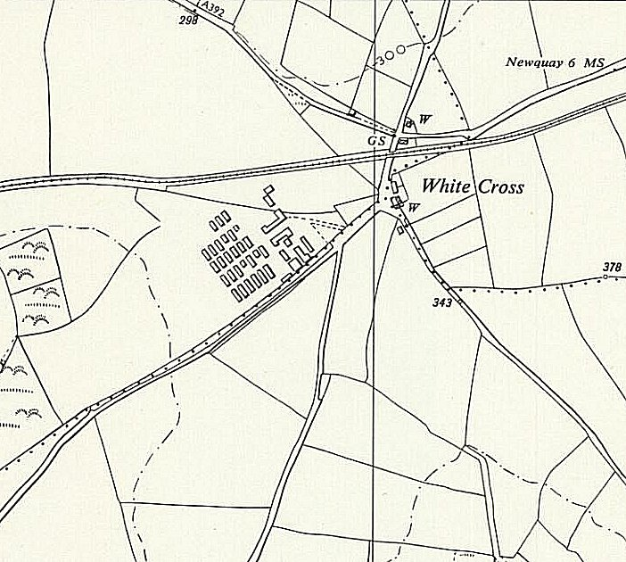
 | Ordnance Survey 1961
league. According to an Italian PoW, they were well treated and given the same food as the local people.” (Wikipedia)

Camp commandant c.1947 Lieutenant Colonel A J B Larcombe, from the Pioneer Corps. (A Lt Col A J B Larcombe is reported to have escorted Hess to Nuremberg in 1945 – is this the same person?).

After the camp: 2019 holiday park, mainly mobile homes.
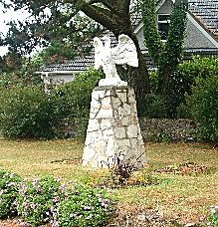 | Further Information:  Der Spiegel, 25 June 1952.  < This picture shows the Italian Eagle at the site of the Camp, taken 2005. (The Eagle has since been moved) WHERE DID IT LAND?  https://commons.wikimedia.org/wiki/File:Wceagle.jpg

