Camp 105 / 105b - Wooler Camp, Brewery Road, Wooler, Northumberland

Included in the 1945 ICRC camp list – Labour Camp. 105. Wooler Camp, Brewery Rd, Wooler, North’mb’d.

1947 Camp list
105(G.W.C.) | Wooler Camp, Brewery Road, Wooler, Northumberland | N. | Priswar, Wooler | Wooler 15 | Belford | Lt.Col.P.H.Phillips | v/1453/2
The entry above has been crossed out in blue crayon and the following details handwritten on.
 | Darras Hall Camp, Ponteland, Newcastle-on-Tyne, Northumberland |  | Ponteland | Ponteland 162 | Newcastle-on-Tyne | Name above has not been crossed out

Prisoner of War Camps (1939 – 1948) - Project report by Roger J.C. Thomas - English Heritage 2003
OS NGR | Sheet | No. | Name & Location | County | Cond’n | Type 1945 | Comments
NT 998 279 | 75 | 105 /b | Wooler Camp, Brewery Road, Wooler | Northumberland | 4 | German Working Camp | STANDARD type. Site occupied by a school

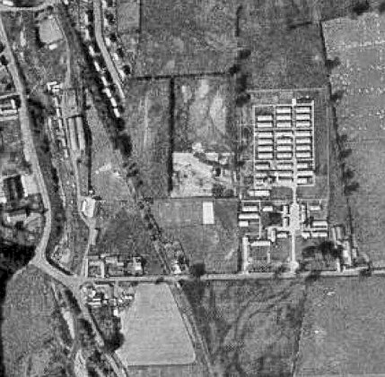 | Location: On the E edge of Wooler.  Before the camp: Farmland next to brewery.  Pow Camp: Italian Pows until at least 1945, then a German Working Camp.  The site had a standard layout with a main pow compound, with guards’ huts and offices at the front. Common buildings and facilities at standard type camps included water towers, offices, officer's mess, a canteen, guard rooms, barrack huts, ablution blocks, cell blocks, a camp reception station (medical facility/hospital), a cookhouse, dining rooms, recreation rooms and living huts.  In 1946 the camp and its hostels had 1134 pows.  One reference in Hansard:  “Mr. Skeffington-Lodge asked the Secretary of State for War whether his attention has been drawn to the death at | 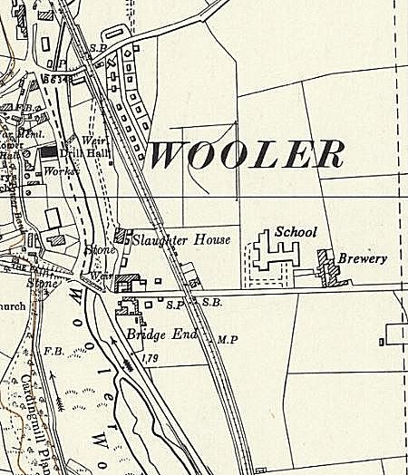
From Facebook, no original attribution. |  | Ordnance Survey 1957
Wooler, Northumberland, of Eugen Mergenthaler, a German P.O.W.; and whether he has any statement to make.

Mr. M. Stewart This prisoner of war was found dead on 8th November. An inquest was held on 10th November and adjourned until 31st December. The matter is being investigated by the civil police.” (House of Commons, 18 November 1947, Volume 444).

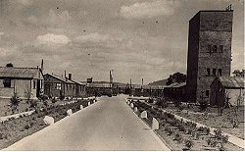 | Further information about this was posted to the WW2talk.com forum by Pete Wood:  “This camp was the scene of a Postwar Murder, by one Prisoner of War against another.  On the 8th November, 1947, the body of Eugen Merganthaler was found bludgeoned to death and his face badly battered. Merganthaler had previously been reported missing and the police had been sent to question the 400 PoWs at the camp, when the body was found by Weetwood Bridge. Merganthaler was due for repatriation in December 1947. He is buried in Cannock Chase.  Burial and death records, plus newspaper clippings, show Merganthaler. But the headstone is spelt Eugen Mergenthaler. | 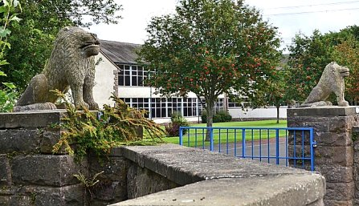  Geograph-4119843 by Jim Barton - St Cuthbert's Way guidebook states these lion gateposts at the entrance to the school were made by Italian pows at the camp.
Karl Kneissler, aged 22, was convicted of the murder (though he always protested innocence) and sent to Lincoln jail. In 1948, Kneissler was sent back to Germany, to finish his sentence.”

(There was a brief mention in Hansard of this case when the Secretary of State for War was asked about a delay to sentencing from the court martial. Mr. Shinwell replied that the confirming authority desired to have a special psychiatrist's report on Kneissler's mental condition. 22 March 1948, Volume 448).

Sub-camps / hostels:
Cornhill (Coldstream)
Craster
Ellingham
Haggerston
Hetton House – was sub-camp 133. Separate details.
Hurworth (nr.Darlington)
Low Lyn (Beal)
Rothbury
Westwood (Wooler)
Whittingham

Camp commandant c.1947 Lieutenant Colonel P H Phillips. (I think he might have been from the Welch Regiment).

After the camp: 2019 A First and Middle School

Further Information:

