Camp 95 - Batford Camp, Harpenden, Hertfordshire

Included in the 1945 ICRC camp list – Labour Camp. 95. Batford Camp, Harpenden, Herts.

1947 camp list
95(G.W.C.) | Batford Camp, Harpenden, Herts | E. | Priswar, Harpenden | Harpenden 3855 | Harpenden | Lt.Col.E.Stoddart. | v/1453/2

Prisoner of War Camps (1939 – 1948) - Project report by Roger J.C. Thomas - English Heritage 2003
OS NGR | Sheet | No. | Name & Location | County | Cond’n | Type 1945 | Comments
TL 148 153 | 166 | 95 | Batford Camp, Harpendon | Hertfordshire | 4 | German Working Camp | STANDARD type.

Location: Batford is a small village on the NE outskirts of Harpenden. The front of the camp was alongside Common Lane.  Before the camp: Part of Batford Common  Pow Camp: Work started on constructing the camp in early 1943, the Italian pows were housed in tents while they built the hutted camp with a capacity of 600. Camp 95 opened in May. 1943. After the Italian Armistice the pows were classed as co-operators. Italian pows until at least 1945, then a German Working Camp.  The site had a standard layout with a main pow compound, with guards’ huts and offices at the front. Common buildings and facilities at standard type camps included water towers, offices, officer's mess, a canteen, guard rooms, barrack huts, ablution blocks, cell blocks, a camp reception station (medical facility/hospital), a cookhouse, dining rooms, recreation rooms and living huts or tents.  During 1944, 21 pows were charged with collective indiscipline after they refused to work, with the main reason being a lack of work clothing. They were punished with detention for up to 28 days and a punishment diet of bread and water, with normal rations every fourth day.  During Spring 1946, a new batch of pows arrived from Canada and the USA. The men had expected to be returned to Germany and their morale was recorded as low. The camp used tents for a short while as additional huts were built.  Re-education activities commenced during 1945 with visiting lectures, a discussion group and films. During 1945 and 1946 there was a wide range of educational lessons for English, French, German literature, history, geography, mathematics, chemistry, physics, applied electricity, building and architecture, and commerce. The range of lessons decreased throughout 1947 as pows were repatriated. | 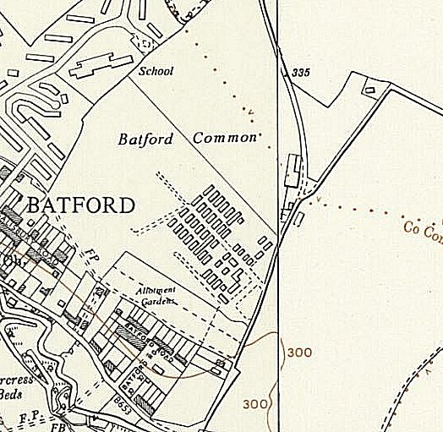
 | Ordnance Survey 1960

There was a camp theatre and library. A camp newspaper was produced. The camp had a radio and loudspeaker system.

A question about the camp arose in the House of Commons:

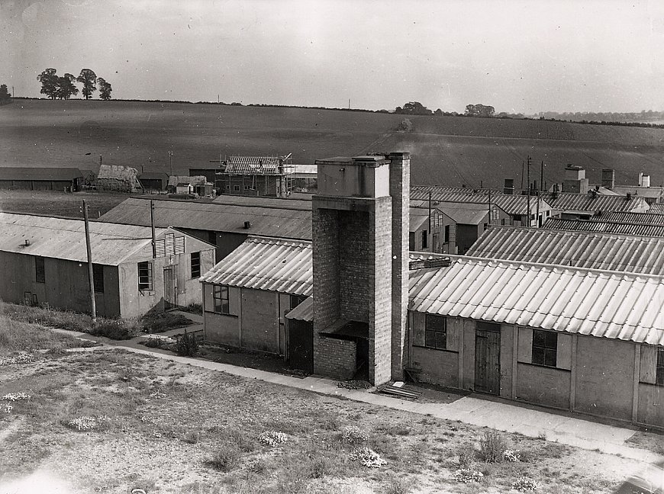 | “Mr. Dumpleton asked the Secretary of State for War why money payments to billeted prisoners of war are distributed each week from Batford Camp, Hertfordshire, by lorry over a wide area; and what petrol consumption is involved in this procedure.  Mr. Shinwell - Billeted prisoners of war administered by this camp are paid once a month, not weekly. It is, however, necessary that they should be visited twice a month, not only that they may receive their pay, but for other administrative purposes, such as clothes changing. A 15-cwt. truck or a light car is used for these journeys and the petrol consumed on them at this particular camp has in the past been approximately eight gallons a month.” (Hansard, 2 December 1947, Volume 445).  < Batford Camp from the collection of Eric Brandreth.  Satellite hostels – Hatfield Hyde – 60 pows, Stanborough – 56 pows and Lemsford – 265 pows.  Camp commandant c.1947 Lieutenant Colonel E Stoddart. (I think he was from the Royal Artillery).  After the camp: Used for emergency housing until 1958. 2019 residential estate.

Further Information:

National Archives FO 939/175 – 95 Working Camp, Batford Camp, Harpenden, Hertfordshire. Dated 1945-1948

Many further details can be found on: http://www.harpenden-history.org.uk/page/no_95_batford_prisoner_of_war_camp?path=0p4p85p

