Camp 94 - Gaulby Road, Billesdon, Leicestershire

Included in the 1945 ICRC camp list – Labour Camp. 94. Gaulby Road Camp, Billesdon, Leicester.

1947 Camp list
94(G.W.C.) | Gaulby Road Camp, Billesdon, Leicester. | N. | Priswar, Billesdon | Billesdon 288/9 | Leicester | Lt.Col.L.Bromley | v/1453/2

Prisoner of War Camps (1939 – 1948) - Project report by Roger J.C. Thomas - English Heritage 2003
OS NGR | Sheet | No. | Name & Location | County | Cond’n | Type 1945 | Comments
SK 717 021 | 141 | 94 | Gaulby Road, Billesdon | Leicestershire | 4 | German Working Camp | STANDARD type.

Location: Just S of Billesdon on the Gaulby Road.  Before the camp: Farmland  Pow Camp: The first Italian pows were accommodated in tents while they constructed the camp. Opened March 1943. Listed as Italian working camp / labour battalion to at least 1945, then a German working camp.  The site had a standard layout with a main pow compound of about 30 huts, and guards’ huts and offices at the front alongside the road. The buildings were mainly wooden construction, with some needing firmer structure, such as the cookhouse, being brick built. Common buildings and facilities at standard type camps included water towers, offices, officer's mess, a canteen, guard rooms, barrack huts, ablution blocks, cell blocks, a camp reception station (medical facility/hospital), a cookhouse, dining rooms, recreation rooms and living huts or tents. There was a library. A hut was used as a theatre / classroom.  For most of its history as a German camp it was classified as ‘grey’ – no strong Nazi views. In 1945 an inspection noted 20 ‘trouble-makers’, and they were removed from this camp. April 1946 classification was A – 124; B – 789; c – 380; Unscreened – 95 / April 1947; A - 9; B - 831; C - 289  Incidental information from a German theatre group journal held by the Deutsches Historisches Museum. The group toured pow camps around England during 1946. It recorded its visit to Gaulby Road Camp, 94 on 31st October - 4th November 1946 (4 performances). | 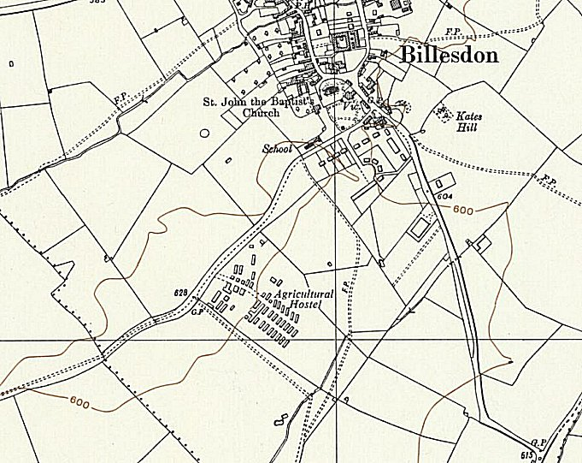
 | Ordnance Survey 1959

Inspections were held on behalf of COGA (Control Office for Germany and Austria) who had oversight of re-education and repatriation. During 1946 there were several education classes, however these fell in range during 1947 as pows were being repatriated. Lack of space for suitable classrooms were frequently commented upon. There was an occasional camp newspaper, and a band/orchestra which played at local events. In 1947 morale was noted as being very good with excellent local relationships

OVERAL NUMBERS | April 1946 | August 1946 | November 1946 | April 1947 | May 1947 | July 1947 | August 1947 | September 1947
 | 1402 | 1222 | 1333 | 1129 | 1300 | 1122 | 1627 | 1337

Inspection Visits | Apr 1946 | May 1946 | Aug 1946 | Nov 1946 | Apr 1947 | May 1947 | Aug 1947 | Sep 1947
Main Camp | 799  (inc billets) | 930  (inc billets) | 819  (inc billets) | 770 | 762  (inc billets) | 780 | 635 | 594 | Huts
Satellite –  Farndon Road | Formerly Camp 49 |  |  |  |  |  | 588 | 425 | Huts
Enderby Hostel  Opened February 1946 | 262 | 262 | - |  |  |  |  |  | ?
Kibworth Hostel  Opened February 1946 | 149 | 149 | 135 | 131 | 100 | 150 | 139 | 150 | Huts
Rearsby Hostel  Opened February 1946 | 131 | 131 | 127 | 129 | 110 | - |  |  | House and huts
Wigston Hostel  Opened February 1946 | 61 | 61 | 54 | - |  |  |  |  | Building
Peckleton Hostel  Opened May 1946 | - | 220 | - |  |  |  |  |  | Building
Somerby Hostel | - |  | 50 | 49 | 36 | 75 | 68 | 71 | Huts
Drayton Hostel | - |  | 37 | 34 | 31 | 40 | - |  | Building
Wartnaby Hostel | - |  |  | 88 | 59 | 100 | - |  | Building
Asfordby Hostel | - |  |  |  | 31 | 40 | 40 | 40 | Huts
Billeted |  |  |  | 132 |  | 125 | 157 | 57

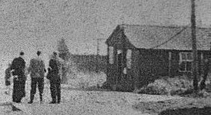 | Camp commandant c.1946-1947 Lieutenant Colonel L Bromley from the Royal Pioneer Corps. Previously commandant at Camp 73, Storwood.  After the camp: The site was used for a short while as a hostel for displaced persons. 2019 waste disposal / council depot and part nature reserve.  Further Information:  National Archives FO 939/174 – 94 Working Camp, Gaulby Road Camp, Billesdon, Leicestershire. Dated 1945-1947  < Wooden huts

