Camp 93 - Harperley Camp, Fir Tree, near Crook, County Durham

Included in the 1945 ICRC camp list – Labour Camp. 93. Harperley Camp, Fir Tree, Bishop Auckland, C.Durham.

1947 camp list
93(G.W.C.) | Harperley Camp, Fir Tree, Bishop Auckland, Co.Durham | N. | Priswar, Crook | Crook 135 (272) | Crook | Lt.Col.G.K.Stobart | v/1453/2

Prisoner of War Camps (1939 – 1948) - Project report by Roger J.C. Thomas - English Heritage 2003
OS NGR | Sheet | No. | Name & Location | County | Cond’n | Type 1945 | Comments
NZ 1269 3553 | 92 | 93 | Harperley Camp, Fir Tree, Crook | County Durham | 1 | German Working Camp | STANDARD type. SCHEDULED

* There is a book with many details about this camp and its sub-camps. I therefore only give an overview and some further information here.

Location: Off the A689.  Before the camp: Farmland. The nearby Harperley Hall was used as a prisoner of war camp during WW1.  Pow Camp: Italian Pows until at least 1945, then a German Working Camp.  At first Italian pows were housed in tents while about 50-55 prefabricated buildings were erected by the prisoners, (1943). Most of the buildings were made from prefabricated concrete slabs. Buildings requiring more structural support, such as the cookhouse and showers, were made from concrete blocks. The pow compound was surrounded by a barbed wire fence, but no guard towers were built.  The site had a standard layout with a main pow compound, and with guards’ huts and offices at the front. Common buildings and facilities at standard type camps included water towers, offices, officer's mess, a canteen, guard rooms, barrack huts, ablution blocks, cell blocks, a camp reception station (medical facility/hospital), a cookhouse, dining rooms, recreation rooms and living huts or tents. Two huts were used as a camp chapel and a theatre.  By September 1944, most of the Italians had dispersed to hostels and farms to make way for an initial batch of 716 German prisoners identified as ‘low risk’, who provided the area with a valuable workforce.  Education inspections were carried out from 1946, they detailed regular classes for English, physics, Latin and Russian. Re-education consisted mainly of visiting lecturers, and from 1947 pows could attend meetings and events outside the camp. There was a theatre group and orchestra.  Camp magazine 'Der Quell' (The Source). | 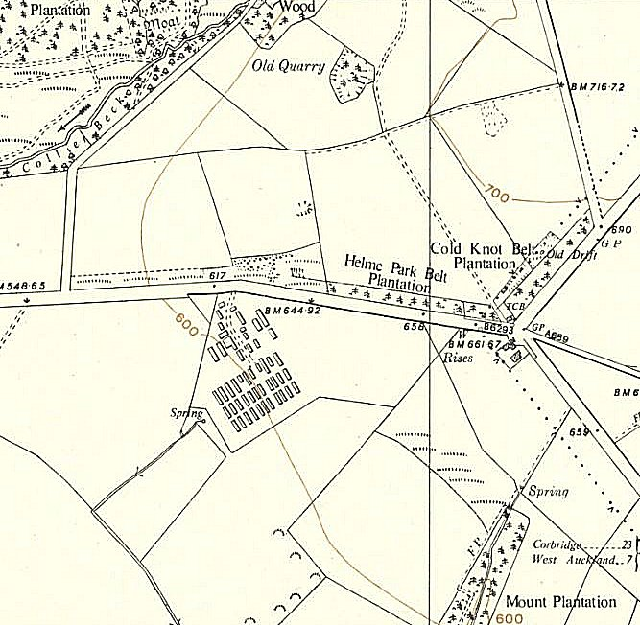
 | Ordnance Survey 1954
One pow hung himself at a farm.
Camp commandant 1943-1945; Major Tetlow
Camp commandant 1945-1948 Lieutenant Colonel George Kinnear Stobart, from the Durham Light Infantry.
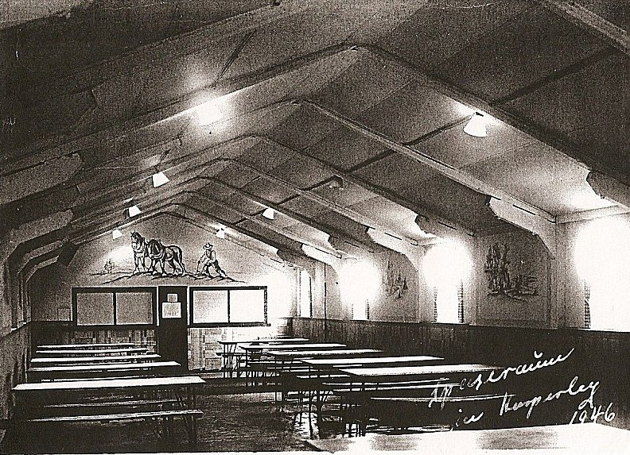 | < The canteen at Harperley in 1946. The wooden panels were decorated with German scenes.  The camp closed in 1948  After the camp: The site was used for a short time for displaced persons. When returned to its owner, it was used for storage and poultry sheds until 1999. Given Scheduled Monument status in 2002, many buildings still exist. Since then it seems to have had a great deal of money in grants and donations in order to open the site as a museum – yet all attempts have failed. 2019, Weardale Cheese is based here.  Further Information:  * Prisoner of War Camps in County Durham, 1944-48; J S Arcumes and J F Helvet – 2002 – County Durham Books.  National Archives FO 939/173 – 93 Working Camp, Harperley Camp, Crook, Durham. Dated 1945-1948.  Vertical aerial photograph RAF 58/2131 0259 28-MAR-1957

There were 10 sub-camps / hostels:  Bedburn – Capacity 150. NGR NZ 093 312 – shown on 1953 OS map >  Formerly moorland, then acquired by the Forestry Commission. Used for a short while for training unemployed people before it became a pow camp. A bathing pool was built here by the pows. One pow was killed in a bicycle accident.  Consett – used for a short term to hold Italian pows due for repatriation.  Hamsterley Hall – Capacity 100  High Spen – Capacity 100  Lanchester – Capacity 100  Langton Grange (Staindrop) – Capacity 150. Langton Grange House and a nearby hostel were used.  Mount Oswald – Capacity 100  Oaklands Hospital, Military POW Hospital, Bishop Auckland – also recorded as Camp 93a. See below.  Usworth – Capacity 100  Windlestone Hall –Capacity 100. Also listed as Camp 4 | 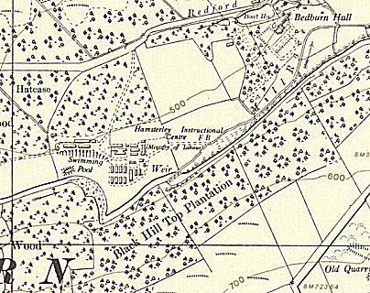

Camp 93a - Oaklands Hospital, Cockton Hill, Bishop Auckland, Co.Durham

Prisoner of War Camps (1939 – 1948) - Project report by Roger J.C. Thomas - English Heritage 2003
OS NGR | Sheet | No. | Name & Location | County | Cond’n | Type 1945 | Comments
NZ 2081 2899 | 93 | 93a | Oaklands Emergency Hospital, Cockton Hill, Bishop Auckland | County Durham | 1 |  | 12 large gable roofed huts still in use as part of the hospital

Location: Alongside the general hospital. 11 large huts, and 1 small, are shown on the 1954 map.  Before the camp: In 1920 the site was marked as Auckland Union Workhouse.  Pow Camp: This was a subsidiary POW Camp to Camp 93, at Harperley. It had a capacity for up to 300 POWs. The prisoners were men with medical training who worked on the wards. The hospital was run by 1/17 Group Emergency Medical Service, it cared for wounded and sick POWs as well as civilians and military personnel.  There was an International Red Cross inspection on 24 June 1944. There were German, Russian and Czech pows.  Commandant of 1/17 EMS; Major A W Neve.  Whittingham’s Hospital nearby, was also used for German pow’s and was inspected by the International Red Cross on 5 August 1944. | 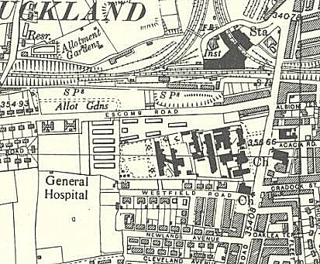
 | Ordnance Survey 1954

