Camp 90 - Friday Bridge Camp, Wisbech, Cambridgeshire

Included in the 1945 ICRC camp list – Labour Camp. 90. Friday Bridge Camp, Wisbech, Cambs.

1947 camp list
90(G.W.C.) | Friday Bridge Camp, Wisbech, Cambs | E. | Priswar, Wisbech | Friday Bridge 253 and 256 | Coldham | (Blank) | v/1453/2

Prisoner of War Camps (1939 – 1948) - Project report by Roger J.C. Thomas - English Heritage 2003
OS NGR | Sheet | No. | Name & Location | County | Cond’n | Type 1945 | Comments
TF 4548 0417 | 143 | 90 | Friday Bridge, Wisbech | Cambridgeshire | 3 | German Working Camp | STANDARD type. Agricultural and youth hostel

Location: About 1.5 km from the small village of Friday Brdge.  Before the camp: Farmland  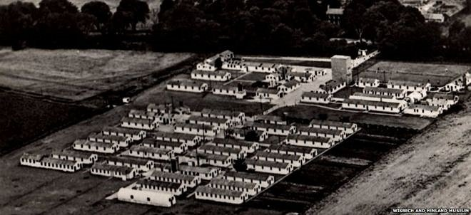  Courtesy of the Wisbech & Fenland Museum | 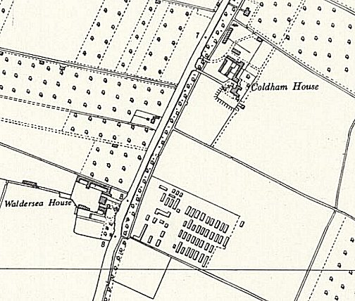
 | Ordnance Survey 1958

Pow Camp: Italian pows up to 1945, then a German working camp. The site had a standard layout with a main pow compound, with guards’ huts and offices at the front. Common buildings and facilities at standard type camps included water towers, offices, officer's mess, a canteen, guard rooms, barrack huts, ablution blocks, cell blocks, a camp reception station (medical facility/hospital), a cookhouse, dining rooms, recreation rooms and living huts or tents.

Ex guard remembers about 2000 German POWs in 1945. There are some references to Ukrainians pows being held at the camp – not confirmed.

One satellite and six hostels:

Bowthorpe Hall Hostel – 4 miles away at Wisbech.
Eastwood House Hostel - 8 miles away at March
Greenlands Hostel – 21 miles away near Kings Lynn.
Hilton Hall Hostel – 14 miles away at Parsonsdrove.
Manea Hostel – 5 miles away at March
Thorney Satellite Camp – also at some time a satellite camp for Sawtry Camp 59
Welney Hostel – 5 miles away at Littleport.

Camp commandant c.1947 – unknown

After the camp: Used as a hostel for migrant workers. 2019 still listed as a hostel, but with new buildings.

In 2013 a former pow, Wilhelm Lagoda, who stayed in England and served 22 years with the Wisbech Fire Service was given ceremonial honours at his funeral.

Further Information:

National Archives FO 939/171 – 90 Working Camp, Friday Bridge Camp, Wisbech, Cambridgeshire. Dated 1945-1948.

The Wisbech and Fenland Museum has some artefacts made by the pows.

