Camp 89 - Easton Grey Camp, Malmesbury, Wiltshire

Included in the 1945 ICRC camp list – Labour Camp. 89. Easton Grey Camp, Malmesbury, Wilts.

1947 Camp list
89(G.W.C.) | Easton Grey Camp, Malmesbury, Wilts | S. | Priswar, Malmesbury | Malmesbury 3112 or 3113 | Malmesbury | Lt.Col.J.G.Selby | v/1453/2
Name crossed out and R.M.Mayhill handwritten

Prisoner of War Camps (1939 – 1948) - Project report by Roger J.C. Thomas - English Heritage 2003
OS NGR | Sheet | No. | Name & Location | County | Cond’n | Type 1945 | Comments
ST 8915 8750 | 173 | 89 | Easton Grey Camp, Easton Grey,  Malmesbury | Wiltshire | 2 | German  Working Camp | STANDARD type. Light industrial and  agricultural use

Location: About 4 km W of Malmesbury.  Before the camp: Farmland  Pow Camp: Italian working camp / labour battalion up to 1945, then a German working camp. The site had a standard layout with a main pow compound, with guards’ huts and offices at the front alongside the road. Common buildings and facilities at standard type camps included water towers, offices, officer's mess, a canteen, guard rooms, barrack huts, ablution blocks, cell blocks, a camp reception station (medical facility/hospital), a cookhouse, dining rooms, recreation rooms and living huts or tents.  Camp commandant c.1947 Lieutenant Colonel G F S Sutton DSC; MC.  Camp commandant c.1947 Lieutenant Colonel J G Selby, from the Royal Artillery.  Camp commandant c.1947 Lieutenant Colonel R M May-Hill, from the Welch Regiment.  After the camp: 2019 a small light industrial site.  Further Information:  National Archives FO 939/169 – 89 Working Camp, Easton Grey Camp, Malmesbury, Wiltshire. Dated 1946-1947  There is an article with pictures of documents belonging to Ciro Muscio an Italian pow who also worked as interpreter in the camp - www.memoriesofwar.org.uk/page_id__154.aspx?path=0p1p3p | 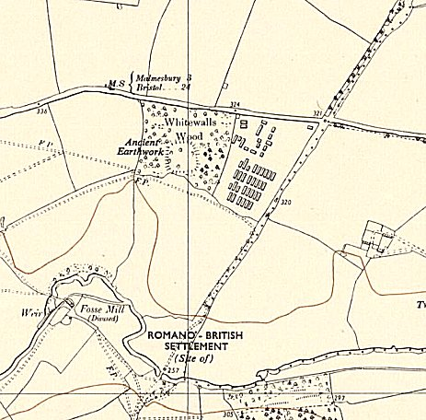
 | Ordnance Survey 1958

