Camp 82 - Hempton Green Camp, Fakenham, Norfolk (aka Pudding Norton)

Included in the 1945 ICRC camp list – Labour Camp. 82. Hempton Green Camp, Fakenham, Norfolk.

1947 Camp List
82(G.W.C.) | Hempton Green Camp, Fakenham, Norfolk | E. | Priswar, Fakenham | Fakenham 2011 | Fakenham | Lt.Col.V.C.Ashe | v/1453/2

Prisoner of War Camps (1939 – 1948) - Project report by Roger J.C. Thomas - English Heritage 2003
OS NGR | Sheet | No. | Name & Location | County | Cond’n | Type 1945 | Comments
TF 910 282 | 132 | 82 | Hempton Green Camp, Hempton, Fakenham | Norfolk | 2 | German Working Camp | STANDARD type. Caravan site

Location: About 1.5 km SW of Fakenham.  Before the camp: Farmland  Pow Camp: Italian pows to at least 1945, then German and other nationality pows. Standard camp layout with a main pow compound and guards’ huts and offices at the front of the camp alongside the road.  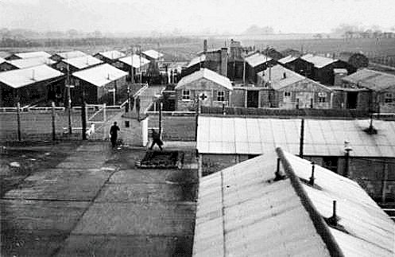  During 1946, some German pows from the US were brought to the camp with low morale as they had expected to be returned to Germany.  Re-education activities were held at the camp from 1946. Records from Wilton Hall show that several pows from Hempton Green attended courses there.  From 1947, the camp held a large number of Ukrainian members of the Waffen-SS Division Galizien which was accused of war-crimes. | 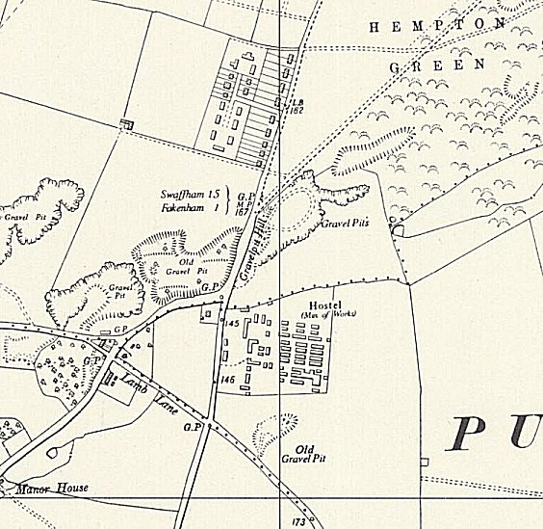
 | Ordnance Survey 1958
Possible sub-camp – Aldborough.

Camp commandant c.1947 Lieutenant Colonel Vivian Charles Ashe from the Royal Regiment of Artillery.

After the camp: The status of the Ukrainian pows changed in 1948 to displaced persons, there were 1,682 recorded at the camp in 1948. For a while the camp was used for emergency housing. 2019 a residential / mobile home area.

< In use 1944

Further information:

National Archives FO 939/162 – 82 Working Camp, Hempton Green Camp, Fakenham, Norfolk. Dated 1945-1947

Vertical Aerial Photograph: RAF. 1946. RAF 3G/TUD/UK/50 6138 31-JAN-1946 (NHER TF9127A).

