Camp 81 - Pingley Farm Camp, Bigby High Road, Brigg, Lincolnshire

Included in the 1945 ICRC camp list – Labour Camp. 81. Pingley Farm Camp, Brigg, Lincs.

1947 Camp List
81(G.W.C.) | Pingley Farm Camp, Brigg, Lincs | N. | Priswar, Brigg | Brigg 3216 | Brigg | Lt.Col.L.J.Paine | v/1453/2

Prisoner of War Camps (1939 – 1948) - Project report by Roger J.C. Thomas - English Heritage 2003
OS NGR | Sheet | No. | Name & Location | County | Cond’n | Type 1945 | Comments
TA 0178 0700 | 112 | 81 | Pingley Farm Camp, Bigby High Road, Brigg | Lincolnshire | 2 | German  Working Camp | STANDARD type. Low grade agricultural use. Assessed unsuitable for Scheduling due to a variety of constraints. See Alternate Action Plan.

There are many entries for this camp, some written in the last few years – most of which begin; “Pingley POW (prisoner of war) camp is one of the few prisoner of war camps in the United Kingdom that remains in good condition….” It was demolished in 2009/10 and is now a housing estate.  Location: Alongside the town of Brigg.  Before the camp: Farmland  Pow Camp: Opened c.1943. Listed as an Italian working camp / labour battalion to at least 1945, then German pows. The camp follows the standard style with a main pow compound; with guards’ huts and offices at the front alongside the road.  “It was built to house 750 low-risk prisoners and consisted of a prisoners' compound, guards' compound, garden plots, recreation ground and a sewage disposal works. A double perimeter fence enclosed the prisoners' compound and the recreation ground.  The guards' compound featured 15 huts, including administration offices, soldiers' quarters and mess, a fuel store, a detention block and a brick water tower. The prisoners' compound occupied a six-acre square area of land and contained 35 huts including a cookhouse, grocery and produce store, two dining huts, two recreation huts, a drying room and showers, two ablution and latrine blocks, a reception station (sick quarters), a carpenter’s hut and 23 living huts.  By May 1946 Pingley Camp held 984 prisoners and additional tented accommodation was erected in the prisoners' compound.”  https://www.pastscape.org.uk/hob.aspx?hob_id=1412084 | 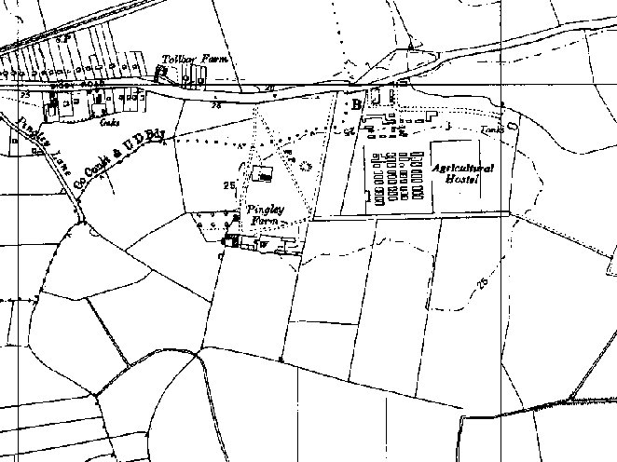
 | Ordnance Survey 1956

A description of the buildings made before the demolition – “The majority of the living huts at the camp are ten-bay MoWP standard huts built using pre-cast reinforced concrete frames and wall panels, but eight of them were Laing composite timber-framed huts clad in weather boarding and internally lined with plaster-board. Secondary cladding with bitumised corrugated iron sheets has since altered the appearance of these huts. All of the MoWP huts used for domestic purposes - cookhouse, ablutions, latrines etc. - were constructed in a different manner to that of the living huts, with hollow clay blocks, or bricks laid on their sides (economy construction) being used in lieu of the concrete panels.

……The largest single structure within the prisoners’ compound was the Camp Reception Station (CRS), also known as the sick bay, hospital, or the Red Cross building. The CRS consisted of three interlinked MoWP huts. The left hand eight-bay range contained the Medical Officer’s Room, Dental Surgeon’s Room, Orderly Rooms and a variety of store rooms, showers and lavatories. The main and isolation wards occupied the twelve-bay central range, while the remaining seven-bay range contained a boiler room, pantry, kitchen, and the Medical Officer’s Bedroom. This building can be found in one form or another at almost all PoW camps, but was not necessarily always built using the same hut types. The example at Camp 81 (Pingley) retains its original plan form and all of the room functions written in Italian can still be read when cross-lit, for example Gabinetto Dentistico (Dental Surgeon), Sula Pulizia (Sluice) etc.

One issue that still remains to be determined relates to the construction of the MoWP huts. Hollow clay blocks were used as nogging in most of the guard compound buildings, and the CRS, cookhouse and dining hall, ablutions, latrines and showers within the prisoners’ compound; the living huts however have concrete panels as nogging. To date no clear explanation has been discovered to explain this difference.
….. In May 1946 Camp 81 (Pingley) was responsible for 1862 prisoners, 984 of whom were housed at the camp and the remainder were either billeted out, or lived at one of four hostels: Elsham Hall, Elsham Mount, Elsham Manor, and Scawby.” (From ‘Prisoner of War camps’ by English Heritage).

Memories - “The German and Italian POWs gave regular unusual concerts, classical and opera and various Brigg organisations were invited.

I was a counters clerk at Brigg Post Office in 1945 and office staff were always invited, transport was provided and after the concert refreshments were served. The standard of the music, singing and instrumental was high class. We had some very enjoyable evenings, the POWs we met were very friendly and polite.” (Rubyn Allen – reported in the Market Raisen Mail, 4 April 2013).

Hostels listed at –  Crowle – NGR SE 777 131 – shown on 1956 map. “October 1946 – 10 PoWs / January 1947 – 55 PoWs / June 1947 – 4 PoWs / September 1947 – Crowle not mentioned in report” (information from crowle.org).  Elsham Hall / Mount / Manor  Scawby  Camp commandant c.1947 Lieutenant Colonel L J Paine. Unable to find further details.  Postal items: POW Postcard 2 May 1948 in German POW to Berlin  After the camp: Used as an agricultural worker's hostel. The camp survived until 2009/10 when it was demolished. Modern map (2019) shows residential area with a garden centre alongside. Examples of prisoner of war artwork survived on the walls of some huts – I am not sure if any of these were preserved.  Further information: | 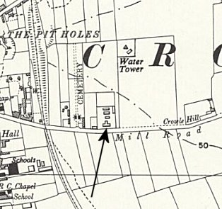
 | Ordnance Survey 1956

National Archives FO 939/161 – 81 Labour camp, Pingley Farm Camp, Brigg, Lincolnshire. Dated 1945-1948.

Note – there are references to a murder at Pingley Camp (Major / Charlie Spasic); this occurred after it was a pow camp, and not actually at the site.

