Camp 79 - Moorby Camp, Revesby, Lincolnshire

Included in the 1945 ICRC camp list – Labour Camp. 79. Moorby Camp, Revesby, Boston, Lincs

1947 Camp list
79(G.W.C.) | Moorby Camp, Revesby, Boston, Lincs | N. | Priswar, Revesby | Mareham-le-Fen 219 | New Bellingbroke | Lt.Col.P.J.M.Ellison | v/1453/2

Prisoner of War Camps (1939 – 1948) - Project report by Roger J.C. Thomas - English Heritage 2003
OS NGR | Sheet | No. | Name & Location | County | Cond’n | Type 1945 | Comments
TF 2981 6378 | 122 | 79 | Moorby Camp, Revesby | Lincolnshire | 1 | German Working Camp | STANDARD type.

Location: About 7 km SE of Horncastle  Before the camp: Farmland  Pow Camp: Listed as Italian working camp / labour battalion to at least 1945, then German working camp. 36 huts in the main pow compound surrounded by barbed-wire fencing. Guards’ huts and offices at the side of the compound.  Ukrainian pows of the Waffen-SS Division Galizien were held here from 1947.  Camp commandant 1944 – Major A Hermelin – not confirmed.  Camp commandant c.1947 Lieutenant Colonel P J M Ellison from the Grenadier Guards  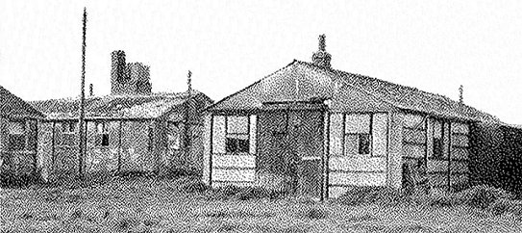  After the camp: In 1948 the 1,264 Ukrainian pows were given displaced person status in the camp. It later became a poultry farm.  Further information:  National Archives FO 939/159 – 79 Working Camp, Moorby Camp, Revesby, Lincolnshire. Dated 1945-1948  Picture from an article on www.revesbyestate.co.uk/ | 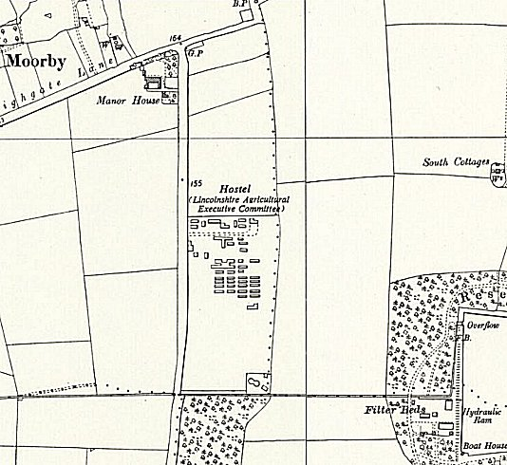
 | Ordnance Survey 1956

