Camp 76 - Merry Thought Camp, Aikbank Common, Calthwaite, Cumberland

Included in the 1945 ICRC camp list – Labour Camp. 76. Merry Thought Camp, Calthwaite, Penrith, Cumberland.

1947 Camp list
76(G.W.C.) | Merry Thought Camp, Calthwaite, Penrith, Cumberland | W. | Priswar, Penrith | Calthwaite 18 | Calthwaite | Lt.Col.T.O.C.Doherty | v/1453/2

Prisoner of War Camps (1939 – 1948) - Project report by Roger J.C. Thomas - English Heritage 2003
OS NGR | Sheet | No. | Name & Location | County | Cond’n | Type 1945 | Comments
NY 4861 4048 | 86 | 76 | Merry Thought Camp, Aikbank Common, Calthwaite | Cumberland | 2 | German Working Camp | STANDARD type.

Location: About 10 km N of Penrith. Why was it called Merry Thought (Merrythought)?  Before the camp: Part of Aikbank Common.  Pow Camp: Listed as an Italian working camp / labour battalion to at least 1945, then a German working camp. The camp has a standard layout with main pow compound and guards’ huts and offices at the front alongside the road.  Memories – “Quite early in the war, Merry Thought Prisoner of War Camp (Camp 76) was built at Calthwaite, about a mile and a half from our farm at Plumpton. During the six months that it took to build the camp, two of the soldiers doing so were billeted with us. One came from Tyneside, the other from Merseyside.  The first occupants of the camp were Italians, one of who, Carlo Agrimi, lived with us for two years. Carlo was a good worker. Occasionally, friends of his from the camp would visit the farm, the most notable of who was the camp tailor, Giuseppe Semminara, who we always knew as Joseph. Joseph made a wonderful Harris Tweed coat for my Father and several skirts for Mother and me. After the war, he returned to Sicily but, in 1949, Joseph came back to England, to start a new tailoring business at Carlisle. When he married a Carlisle girl he asked my parents to represent his parents at the wedding, which I think would have been in 1953. Joseph died four or five years ago. His venture was extremely successful and, if memory serves, as many as fifteen other Italians followed, first to work for or with Joseph before they branched out into other ventures.  When the Italians were moved out of the Prisoner of War camp German prisoners moved in. Again, we had one billeted with us, to work on the farm. Unfortunately, I cannot remember his name but he, too, was a very good worker. He kept in touch when he returned to Germany and I remember him sending us a copy of his wedding photograph.” (Story by Ella Thwaites (nee Richardson) contributed by newcastlecsv to ‘bbc.co.uk/ww2peopleswar' – 2005). | 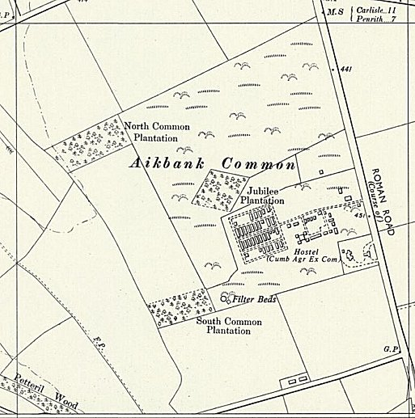
 | Ordnance Survey 1956

MEMORIAL DETAILS

A hostel is recorded at Brampton, Cumberland, (from ‘Leben und Lernen hinter Stacheldraht’).

Camp commandant c.1947 Lieutenant Colonel T O C Doherty. I think this was Terence O’Cahir Doherty of the Essex Regiment.

Carlisle Archive Centre Document reference DFCRC 1/62 is a memorial card to LC. On the front page is PAX symbol – inside inscription reads: “And now abideth faith, hope, charity, these three; but the greatest of these is charity – 1 Cor 13.13 / The Catholic Camp Parish of POW Camp 76 Merrythought gives thanks to the Commandant Lt Colonel T.D.C. Doherty for all the work of mercy and all the trouble he took in the fitting out of the catholic camp chapel, On this day of the Solemn Mass of Thanksgiving for all donors of charitable gifts, we ask our Lord to reward the love of English Catholics who gave them to our chapel through the mediation of the Commandant and to give them his blessing.” This was originally given to Lt Col T.D.C. Doherty. © WMR-66852 The middle initial would seem to be an error.

Lt Col Doherty moved to become Commandant of Sheet Camp 84.

Postal items: POW letter-sheet 22 November 1945 in Italian to Italy.

After the camp: Mainly woodland.

Further information:

National Archives FO 939/156 – 76 Working Camp, Merry Thought Camp, Calthwaite, Cumberland. Dated 1946-1948

