Camp 71 - Sheriffhales Camp (Sheriff Hales), Shifnal, Shropshire

Included in the 1945 ICRC camp list – Labour Camp. 71. Sherriffhales Camp, Shifnal. Shropshire.

1947 Camp List
71(G.W.C.) | Sheriffhales Camp, Shifnal, Salop. | W. | Priswar, Sheriffhales | Shifnal 100 | Shifnal | Major B.Wright | v/1452/2

Prisoner of War Camps (1939 – 1948) - Project report by Roger J.C. Thomas - English Heritage 2003
OS NGR | Sheet | No. | Name & Location | County | Cond’n | Type 1945 | Comments
SJ 757 115 | 127 | 71 | Sheriffhales (Sheriff Hales) Camp, Shifnal | Shropshire | 4 | German Working Camp | STANDARD type.

Location: Off the Sheriff Hales Drive. About 7km NE of Telford.  Before the camp: Farmland  Pow camp: Listed as an Italian working camp / labour battalion to at least 1945, then German pows. (Several sources state that German pows replaced the Italians in 1943 – this is incorrect).  Memories – “As the first batches of Italians were marched down from Shifnal to Sheriffhales camp, the locals booed them through the town. Opinions slowly changed as social barriers broke down. ‘I was treated like a son’ said Italian Angelo Toffanin of the farmer who employed him. Local women bought hungry-looking PoWs packets of fish and chips, much to the displeasure of the English soldiers guarding them.” (Wellingtonia, Issue 1, Autumn 2008, the Newsletter of the Wellington History Group).  Initially a large camp with 2000 pows. However, in the 1947 list it has a War Establishment Number for a smaller camp, and likewise the rank of the Commandant is major, not Lieutenant Colonel.  Record that pow Wilhelm Kunz killed himself by throwing himself onto a railway line near Shifnal, (date?).  Reported that the camp was open until 1948 – not confirmed.  After the camp: Housed European Voluntary Workers for a few years. | 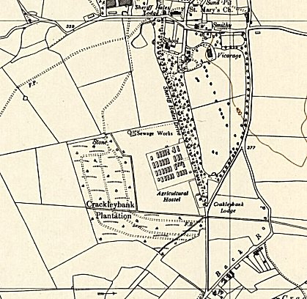
 | Ordnance Survey 1954

