Camp 71 - Lower Hare Park, London Road, Newmarket, Cambridgeshire

Prisoner of War Camps (1939 – 1948) - Project report by Roger J.C. Thomas - English Heritage 2003
OS NGR | Sheet | No. | Name & Location | County | Cond’n | Type 1945 | Comments
TL 592 595 | 154 | 71 | Lower Hare Park, London Road, Newmarket | Cambridgeshire | 4

Location:  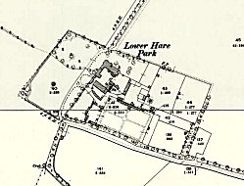  I have not found any information for this camp.  The site shown at the NGR looked likely to be a pow compound, but it is not - as can be seen from the inset map on the left that was made in 1902.  There is no description for the camp. I have looked up contemporary lists for camps in 1940 / 1945 / 1947 and it is not listed in any of those. I can find no National Archive reference to the camp, and I have failed to find anything at all online!  There was another camp (Sheriffhales) numbered 71 from 1943 to 1947/8 – so the camp at Lower Hare is unlikely to have existed during that time, unless it changed its camp number and there is no record of that. That only leaves a short time period of 1941-1943. | 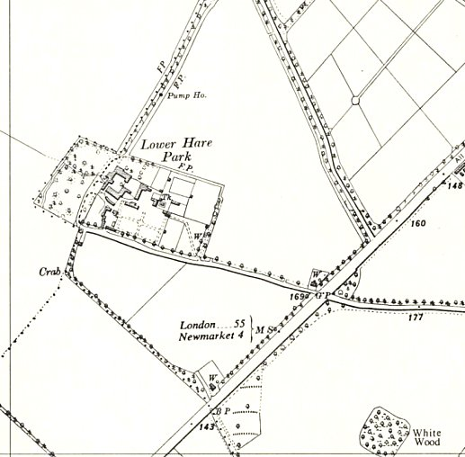
 | Ordnance Survey 1958

