Camp 67 - Sandyhillock Camp, Craigellachie, Banffshire

Included in the 1945 ICRC camp list – Labour Camp. 67. Sandyhillock Camp, Craigellachie, Banffs.

1947 Camp List
67(G.W.C.) | Sandyhillock Camp, Craigellachie, Banffshire. | Sc. | Priswar, Craigellachie | Carren 225 | Craigellachie | Lt.Col.H.Lawton, M.B.E. | v/1453/2

Prisoner of War Camps (1939 – 1948) - Project report by Roger J.C. Thomas - English Heritage 2003
OS NGR | Sheet | No. | Name & Location | County | Cond’n | Type 1945 | Comments
 |  | 67 | Sandyhillock Camp, Craigellachie | Banffshire |  | German Working Camp | Scotland

Location: NGR NJ 256 449. 1946 aerial photograph shows the camp to be 275m S of Sandyhillock farm. About 3.5 km W of Craigellachie. (Rothes is about 5 km away, there may have been an associated camp, or it could be the same camp).  Before the camp: Farmland  Pow camp: Listed as an Italian working camp / labour battalion to at least 1945, then a German Working Camp.  Main compound for pows had at least 39 Nissen type huts enclosed by a barbed wire fence. About 27 guard huts and offices alongside the B9102 road. There was a recreation area and sewage works.  Memories of the camp by Jean Mark – “Each day a lorry would bring a group of men from the camp to work at the farm. The 4 or 5 mostly young single men enjoyed working at the farm. They brought pieces of bread with them along with ground coffee and Jean’s mother made them dinner with everyone else. Initially she had to be shown by one of the Italian POWs called Mario how to make coffee.  Later on in the war German POWs also arrived at the camp. Towards the end of the war or just after her mother decided one day to take two of the POWs to the local cinema as a treat. As this sort of activity was not allowed for POWs she had to dress the two Germans up in long black overcoats to hide the PW lettering on their trousers below their knees along with the PW written across the backs of their black tops.  After the war Eric Penno, one of the German POWs stayed behind. Eventually he married Margaret, one of Jean’s sisters. He did return to Germany to see his family after war, but returned to continue working at Bomakelloch.” (Recorded by Moray Heritage Memory Project ).  There are details of at least two deaths at the camp: | 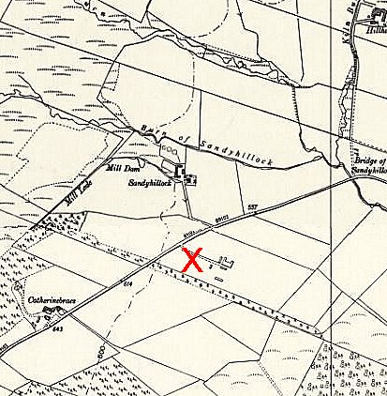
 | 1959 Ordnance Survey
Elgin Sheriff Court, Record of Fatal Accidents –

“Ferdinando Iannetti, Italian prisoner of war, 67th Prisoner of War Camp, Sandyhillock, Elchies, Knockando Parish, Morayshire, died 31 Jan 1944 as a result of drowning”, (National Records of Scotland, Ref SC26/28/1944/2).

“Alfred Birner, B206381, German prisoner of war, 67th Prisoner of War Camp, Sandyhillock, Knockando Parish, Morayshire, died 21 Aug 1947 as a result of injuries sustained falling off the back of an army motor lorry”, (National Records of Scotland, Ref SC26/28/1947/3).

Postal items: Letter-sheets 3 September 1944 and 5 December 1945 in Italian to Italy.

After the camp: A poultry farm was located on the site. Now Speyside Camping and Caravanning Site.

Further information:

National Archives FO 939/148 – 67 Working Camp, Sandy Hillock Camp, Craigellachie, Banffshire. Dated 1945-1948.

Canmore - http://canmore.org.uk/site/272620

Vertical air photograph (106G/Scot/UK169, 2068, flown 26 August 1946)

