Camp 113 - Holm Park Camp, Newton Stewart, Wigtownshire

Included in the 1945 ICRC camp list – Labour Camp. 113. Holm Park Camp, Newton Stewart, Wigtownshire.

1947 Camp list
113(G.W.C.) | Holm Park Camp, Newton Stewart, Wigtownshire | Sc. | Priswar, Newton Stewart | Newton Stewart 215/6 | Newton Stewart | Lt.Col.J.D.Vans-Agnew | v/1453/2

Prisoner of War Camps (1939 – 1948) - Project report by Roger J.C. Thomas - English Heritage 2003
OS NGR | Sheet | No. | Name & Location | County | Cond’n | Type 1945 | Comments
 |  | 113 | Holm Park Camp, Newton Stewart | Wigtownshire |  | German Working Camp | Scotland

Location: NGR NX 415 655. On the E edge of Newton Stewart.  Before the camp: Farmland alongside a football ground.  Pow Camp: Listed as an Italian working camp / labour battalion to at least 1945, then a German Working Camp.  Map shows a standard type layout with a main pow compound, and guards’ huts and offices at the front alongside the road.  There were two Fatal Accident Inquiries for Italian pows at this camp, unfortunately both have only basic entries:  17 September 1943, Kirkcudbright Sheriff Court - Sirio Rossi, prisoner of war, Italian Army (No 194776), Holmpark Camp, Creebridge, Kirkcudbrightshire, died 14 Aug 1943 as a result of injuries sustained on 13 Aug 1943 (National Records of Scotland Ref SC16/25/1943/1)  28 June 1945, Kirkcudbright Sheriff Court – Alberto Innocenti, prisoner of war, Italian Army (No 117216), Holmpark Prisoner of War Camp, Creebridge, Minnigaff Parish, Kirkcudbrightshire, residing at Ard-na-Ghyll, Kirkcudbrightshire, died 14 Jun 1945 (National Records of Scotland Ref SC16/25/1945/1)  In Monigaff Church (in Minnigaff), inside the vestibule there is a sculpture of life size praying hands. These were carved by an Italian P.O.W during the second world war as a thank you to the Parish.  Camp commandant c.1947 Lieutenant Colonel J D Vans-Agnew (Not sure if this is J B Vans-Agnew of the Kings Own Scottish Borderers). | 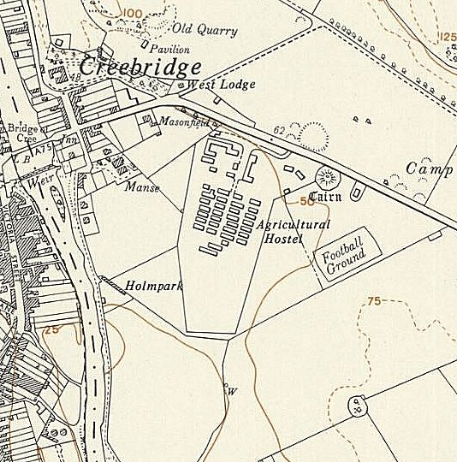
 | Ordnance Survey 1957
After the camp: Agricultural Hostel. 2019 camping and caravan park.

Further Information:

http://canmore.org.uk/site/180286

RAF aerial photographs - 1945 (106G/UK 986: 4022-4023

