Camp 112 - Kingencleugh Camp, Mauchline, Ayrshire

Included in the 1945 ICRC camp list – Labour Camp. 112. Kingencleugh Camp, Mauchline, Ayrshire.

Prisoner of War Camps (1939 – 1948) - Project report by Roger J.C. Thomas - English Heritage 2003
OS NGR | Sheet | No. | Name & Location | County | Cond’n | Type 1945 | Comments
 |  | 112 | Kingencleugh (Kingendengh) Camp, Mauchline | Ayrshire |  | German Working Camp | Scotland

Location: NGR NS 503 259. Just S of Mauchline.  Before the camp:  Pow Camp: Listed as Italian working camp / labour battalion to at least 1945, then German pows.  Closed 1946 – the camp number going to Doonfoot (Camp 14 / 112).  Postal items: Letter-sheets 19 July 1943 and 22 February 1944 in Italian to Italy.  After the camp: Third Statistical Account, page 699: 'It was hoped at one time that the Prisoners of War Camp at Kingencleugh, from which some 500 prisoners, first Italians and later Germans, went out to labour on farms in the districts around, might be made available for local housing once the Germans had gone home, but it is now [1951] occupied by "displaced persons" from Central Europe.' 2019 farmland  On 20 September 1944, an Italian POW from Camp 112 - G Carrozza - was sentenced to 42 days detention for the offence of; “Conduct prejudicial to good order and discipline among P.O.W. in that he in the field between 15 June 43 and 30 April 44 consorted and associated with and engaged in sexual intercourse with Elena Bove a civilian woman.” Carrozza had been tried at Camp 123, Dalmahoy. The original detention order is at http://www.sfizidiposta.it/2018/07/06/si-intratteneva-sessualmente-con/  Further Information:  http://canmore.org.uk/site/180976  Royal Air Force aerial photograph taken in 1946 (CPE/Scot/UK 176: 2130). | 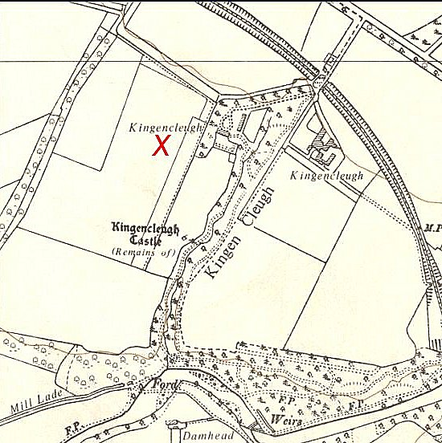
 | Ordnance Survey 1958

