Camp 111 - Deer Park Camp, Monymusk, Aberdeenshire

Included in the 1945 ICRC camp list – Labour Camp. 111. Deer Park Camp, Monymusk, Aberdeen.

1947 Camp list
111(G.W.C.) | Deer Park Camp, Monymusk, Aberdeen | Sc. | Priswar, Monymusk | Monymusk 29 | Monymusk | Major T.Smith | v/1452/2
The entry above has been crossed out in blue crayon and the following details handwritten on.
 | Harlaw, Inverurie, Aberdeenshire |  | Inverurie | Inverurie 209 | Inverurie | Name has not been crossed out

Prisoner of War Camps (1939 – 1948) - Project report by Roger J.C. Thomas - English Heritage 2003
OS NGR | Sheet | No. | Name & Location | County | Cond’n | Type 1945 | Comments
 |  | 111 | Deer Park Camp, Monymusk | Aberdeenshire |  | German Working Camp | Scotland

Location: NGR NJ 684 155  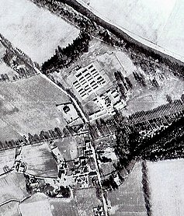  Before the camp: Deer Park  Pow Camp: Listed as Italian working camp / labour battalion to at least 1945, then a German Working Camp.  “The huts at Monymusk had a concrete base and frame, and were built from hollow bricks with a pitched corrugated asbestos roof... They were heated by a pot-bellied stove and those at Monymusk housed 35 men sleeping on simple wooden bunks. There were also blocks for the latrines, wash-houses, cook house, boiler house, canteen, stores and medical areas.  Sporting activities, workshops, concerts and lectures were put on inside the camp. Mr Whiteley who was the Dominee of Monymusk School gave Monday evening English lessons to the prisoners. Many of the PoWs worked at the farms in the area and had picked up some of the local Scots words, for example when Mr Whiteley was teaching them the English word for 'potato', he was corrected by the PoWs with "na, na, tatties"!  Some of the Catholic refugees built a small chapel in one of the huts. They constructed the altar from wood, cardboard and tin and a Ukrainian artist decorated it with paintings of famous Saints and a copy of Leonardo Da Vinci's Last Supper over the altar. There was also an elaborate chandelier made from biscuit | 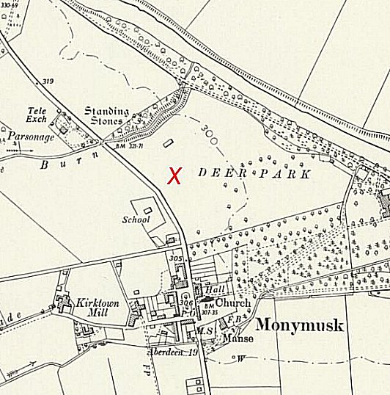
 | Ordnance Survey 1958
tins. Mrs Whiteley attended the inauguration ceremony for the chapel and later said she was "moved to see those weather beaten faces with tears on their cheeks." After the ceremony there was a dinner celebration of bortsch which is an eastern European dish made from beetroot.” (details from https://www.monymusk.com/ )

There was an International Red Cross inspection on 28 May 1943 - Italian prisoners, capacity 750.

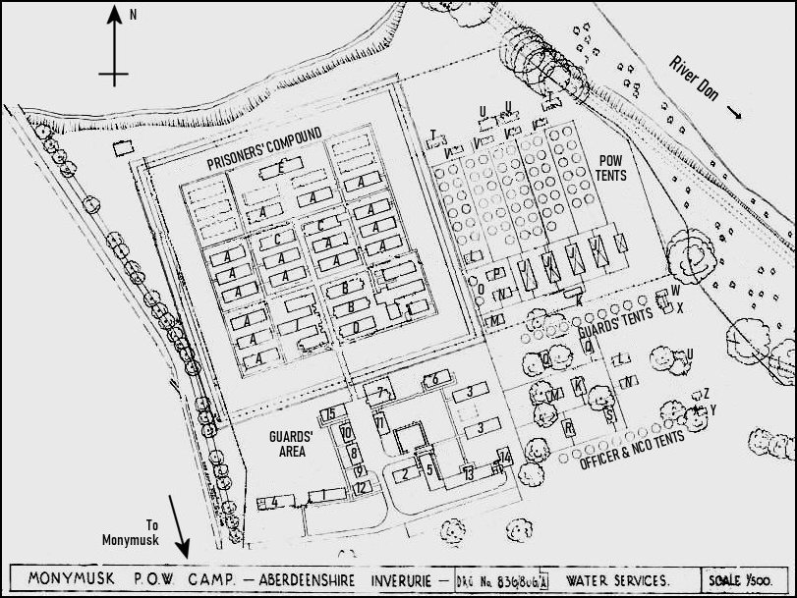 | 1943 Plan of the Camp  Note, I have enhanced the original plan.  Prisoners’ Section  A B C D E F G H I Living hut Dining hut Ablutions & latrines Recreation hut Drying room & showers Cookhouse Workshops (shoemaker, tailor, barber) Grocery & local produce store Reception  Guards’ Section  1 2 3 4 5 6 7 8 9 10 11 12 13 14 15 Officers’ living hut & latrines WOs’ & sergeants’ living hut & mess Guards’ living hut Officers’ mess & ablutions Guards Cookhouse & Showers Guards’ ablutions, latrines & drying room Detention block Quartermaster’s office Water tower & quartermaster’s store Company office & store Guard hut & small arms ammunition Store Tool shed and M/A officer Regimental institute & guards’ dining Commandant’s Office  Tented Area  J K L M N O P Dining Tent Cookhouse Recreation Orderly Drying Office Tent Technical

Q  R  S | Guard Dining  Officer Dining  Warrant Officers & Sergeants Dining | T  U  V | Latrines  Showers  Ablutions | W  X  Y | Guards Ablutions  Guards Latrines  Officers Ablutions & Latrines | Z | Warrant Officers & Sergeants Ablutions & Latrines

At the back of the pow compound there appears to have been plans to build some additional huts – these were not completed as shown in a later 1947 plan.

The tented areas were removed later.

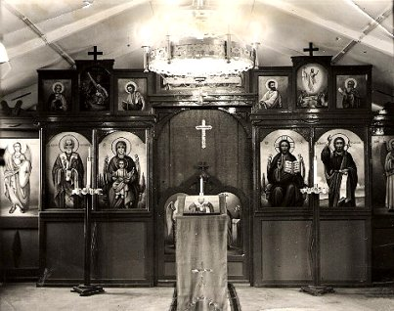 | Memories – “Italian POW’s from the nearby camp at Monymusk were also to be seen in the village in the latter war years. These gentlemen provided labour for the local farms and were often transported through the village on lorries to the various farms. They were generally a friendly and amiable lot with little interest in the war, they seemed to have more interest in ogling the local girls. I remember that one of my friends had told me a rather rude and offensive Italian phrase and on the next occasion when the POW’s were being transported through the village, I shouted this phrase at them. My Italian was obviously understood for an enraged Italian jumped from the lorry and rushed towards me. I took off up the main street pursued by the Italian followed in turn by a rather bemused guard. I decided there and then to avoid any further experiments with the Italian language.” (World War II Memories of Alastair Craig - http://www.kemnay.info/history/world-war-ii/?LMCL=on9qDN ).  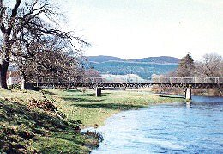  The bridge over the River Don by Enzean Farm was constructed by German and Italian PoWs from the camp. Apparently the two nationalities refused to work together and every second day would change.  On 8 August 1947, there was a fatal accident Inquiry at Aberdeen Sheriff Court -  “Erick Behrendt, German prisoner of war, No. 111 Prisoner of War Camp, Monymusk, Aberdeenshire, died on 25 Aug 1947 at the camp from injuries sustained on the same day in the railway station yard at Monymusk when he was struck on the left shoulder and neck with a wooden board.” (Scottish National Records Office – ref SC1/16/1947/13)
Moneymusk Chapel – sadly demolished.

There was a camp newspaper called; ‘Deer Park Ring’  A satellite camp based at Alford. Grid reference NJ 572 162 (X). “…held mainly Italian prisoners, with possibly some German prisoners at a later date. The huts were later used as an egg-packing station, but have now been demolished.”  Camp commandant c.1947 Major T Smith  After the camp: Site used to house displaced persons under the European Voluntary Worker scheme. Huts gradually sold. 2019 residential area.  Further Information:  The Monymusk estate website ( https://www.monymusk.com/ ) has plans for:  Monymusk POW Camp, Water Services, Ministry of Works, Sanitary Eng. Branch, Edinburgh, 1943.  Monymusk POW Camp, Layout of S.D. (Sewage) Works, Ministry of Works, Sanitary Eng. Branch, Edinburgh, 1944.  Monymusk Home Farm, Deer Park Field , 1947 (former POW camp)  Ordnance Survey Map of Monymusk Camp, 1977  http://canmore.org.uk/site/107500  Vertical air photograph 58/RAF/1296 F21 0071, dated 15 October 1953  IWM have a copy of the camp newspaper from February 1947 – Reference LBY E.J. 344 | 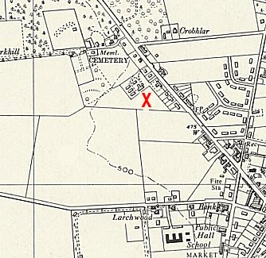
 | Ordnance Survey 1957

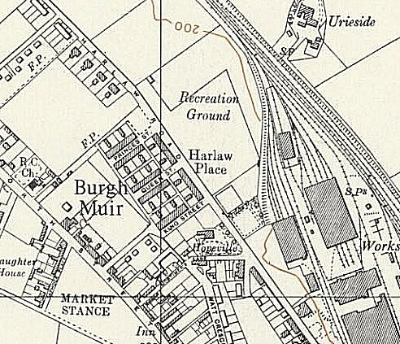 | The alteration to the 1947 camp list for Camp 111 becoming; ‘Harlaw, Inverurie, Aberdeenshire’ - is not resolved.  1. Note the title on the 1943 plan – ‘Moneymusk POW Camp – Aberdeenshire Inverurie’.  However,  2. Harlaw / Inverurie Camp is not listed. Inverurie is about 9 miles NE of Monymusk. On the North of Inverurie is Harlaw Place at NGR NJ 771 222 on the 1959 Ordnance Survey map. This would seem a likely location based on the new address details.  But, was this a separate camp – or a satellite to Monymusk? In another camp, as the main camp decreased in size with the repatriation of pows, the remaining men were transferred to a sub-camp and the main closed – is that the case here?

