Camp 110 - Stuartfield Camp, Mintlaw, Aberdeenshire (aka Crichie)

Included in the 1945 ICRC camp list – Labour Camp. 110. Stuartfield Camp, Mintlaw Station, Aberdeenshire.

1947 Camp list
110(G.W.C.) | Stuartfield Camp, Mintlaw Station, Aberdeenshire | Sc. | Priswar, Mintlaw | Stuartfield 211 | Mintlaw | Lt.Col.J.S.Spencer, O.B.E. M.C. T.D. | v/1453/2

Prisoner of War Camps (1939 – 1948) - Project report by Roger J.C. Thomas - English Heritage 2003
OS NGR | Sheet | No. | Name & Location | County | Cond’n | Type 1945 | Comments
 |  | 110 | Stuartfield Camp, Mintlaw Station | Aberdeenshire |  | German Working Camp | Scotland

Location: NGR NJ 974 449. About 3.5 km S of Mintlaw Station.  Before the camp: Farmland  Pow Camp: Listed as Italian working camp / labour battalion to at least 1945, then German pows.  There was an International Red Cross inspection on 28 May 1943 - Italian prisoners, capacity 500.  A fatal accident inquiry was held for an Italian pow, 1 October 1945. Aberdeen Sheriff Court. National Records of Scotland; Reference SC1/16/1945/21  “Guerrino Gramola, private, Italian Army (prisoner of war), Stuartfield Prisoner of War Camp, Mintlaw, died on 26 May 1945 while travelling on a train between Mintlaw and Aberdeen, when he jumped off the train on to the line.”  There was a camp newspaper – ‘Nordlicht’ (Northern Lights)  Camp commandant c.1947 Lieutenant Colonel J S Spencer, O.B.E. M.C. T.D., from 6 BN Duke of Wellington’s Regiment.  Postal items: Letter 11 March 1947 to German POW in camp  After the camp: Site used to house displaced persons. 2019 Farm  Further Information:  http://canmore.org.uk/site/264794  IWM hold a copy of Nordlicht from Jan-Feb 1947. Catalogue LBY E.J. 403 | 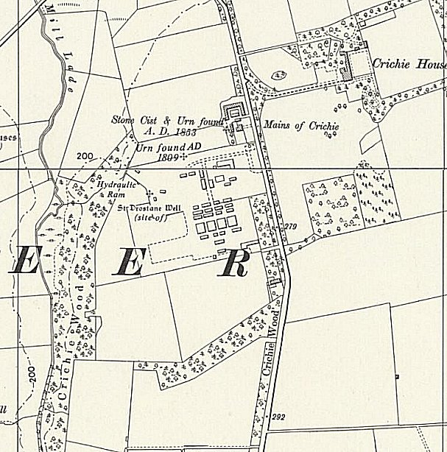
 | Ordnance Survey

There was also a fatal accident inquiry for a German pow, 25 November 1947. Aberdeen Sheriff Court. National Records of Scotland; Reference SC1/16/1947/17

“Ernest Knappenberger, German prisoner of war No. 661516, Prisoners of War Camp, North Blachrie, Fyvie, Aberdeenshire, died on 21 Oct 1947 cycling on the Cuminestown-Fyvie road, and at a part thereof 100 yards south of the Cottage Hospital, parish of Fyvie, Aberdeenshire, when he collided at Hillhead Cottage, Fyvie, and was thrown to the ground.” NOTE the camp recorded is a sub-camp – was it for Camp 110 or Camp 111, also in Aberdeenshire?

