Camp 109 Brahan Castle (Estate), Dingwall, Ross-shire

Included in the 1945 ICRC camp list – Labour Camp. 109. Brahan Castle Camp, Dingwall, Ross-shire.

1947 Camp list
109(G.W.C.) | Brahan Castle Camp, Dingwall, Ross-shire | Sc. | Priswar, Cononbridge | Cononbridge 266 | Dingwall | Lt.Col.K.G.O’Morchoe | v/1453/2

Prisoner of War Camps (1939 – 1948) - Project report by Roger J.C. Thomas - English Heritage 2003
OS NGR | Sheet | No. | Name & Location | County | Cond’n | Type 1945 | Comments
 |  | 109 | Brahan Castle, Dingwall | Ross-shire |  | German Working Camp | Scotland

Location: NGR NH 517 554. On the A835, 18 km NW of Inverness.  Before the camp: Country estate. Left in trust 1923. Estate used for army training.  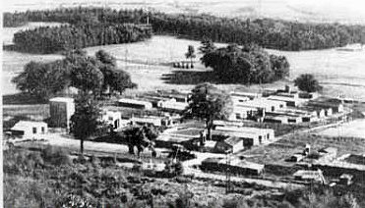  Pow Camp: Italian, then German pows.  < The A835 can be seen at the bottom of the picture, with the camp alongside. (www.rossandcromartyheritage.org/ )  A brief description of the camp – 1946, Marching from Dingwall Station; “…Passing a village on our left [Maryburgh] we saw a number of huts just off the main road, another camp with many timber huts.  We were all tired after the long march. In the US we always had transport. We were assigned to our accommodation and instructed to line-up for food within half an hour. The huts were more comfortable than those at distant Cultybraggan and should be warmer, we thought.,,, we learned we were at German PoW Camp 109 at Brahan Castle. This was a main camp serving several smaller ones.” (*ref below)  Sub-camps:  Belladrum Camp near Kiltarlity. Formerly a Canadian Forestry Corps Camp.  Bruiach Camp. Site also used as WW1 camp. During WW2 used by Lovat Scouts, then Italian pows and possibly Germans. | 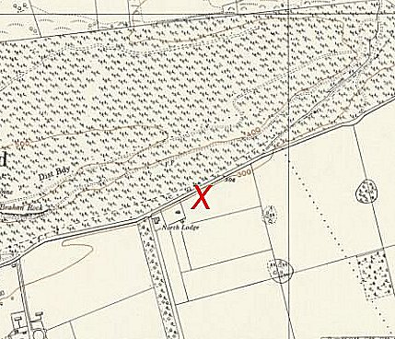
 | Ordnance Survey 1959

Clunevackie Camp. Site used as WW1 camp. During WW2 site used by Canadian army, then pow camp. Germans reported as arriving c1945-6
Dell Camp – mentioned in Sheriff’s report, below.

Kildary. About 27 km NE of Dingwall. About 50 pows. “Two Barracks provided our living accommodation. They were prefabricated concrete buildings, which should be warmer. There was one toilet in each barrack. The main washroom was next to the kitchen and the guardhouse. Our cook inspected his new domain, indicating that both kitchen and mess-room were satisfactory. Two solid-wood stoves for each barrack provided heating. We discovered that Italian POWs had been billeted here before us, and had left a concrete Mussolini emblem on the gable of the kitchen.” (* ref below). Minimal security, a low wire fence.

Teanacoil Camp

30.5.45. Tel. No. Conon Bridge 211  A/21/34/45 Subject: P.W. Labour 30 May '45  To: All employers of PW Labour:  It has been brought to the notice of the Commandant of this Camp, that Employers of Italian Prisoner of War Billetees, both Co-operator and Non-Co-operator, are not complying with the instructions re the behaviour of Italian P.W. Billetees.  Co-operator Billetees - Church: if within 5 miles.  Are permitted to go to cinema if within the radius of 5 miles from their Billet. They are NOT permitted to enter Dance Halls or Public Houses.  If an employer of Billetees permits the Italian P.W. employed by him to break these rules - labour will be withdrawn immediately.  TAIN is out of Bounds to all P.Ws on Saturday evenings.  Daily Workers. It has come to the notice of the Commandant that Daily Workers are being fed by some employers. This is not permitted and furthermore is not fair to your neighbouring farmers who are unable to afford to do this, with lowered scale of rationing. It encourages the P.Ws to be discontented with their employment.  I would remind you that:-  All P.Ws get their full scale of rations in camp. All P.Ws. bring out with them daily haversack rations - these are often thrown away because of meals given as already mentioned. The Commandant asks that you help yourselves by helping each other.  Would you please give the attached slip printed in Italian to your billetee, it has full instructions to him regarding the above.  (Signed) Thornton Smith, Capt.  Acting Commandant. | < Transcript of a letter held by Dingwall Museum.  There was a suicide at the camp: Dingwall Sheriff Court – Records of Fatal Accident Inquiries (National Records of Scotland – Reference SC25/15/1946/1).  “Fritz Saalbach, German prisoner of war, 109 German Working POW Camp, Brahan, Conon Bridge, hanged himself on 25 June 1946 in bathroom of prisoners' compound, 22 July 1946.”  There was also a fatal accident: Inverness Sheriff Court - Records of Fatal Accident Inquiries (National Records of Scotland – Reference SC29/27/12/35).  “Fritz Endres, German prisoner of war under detention, No. 109 German Prisoner of War Camp, Brahan, Dingwall, motor tractor driver, residing at Dell Camp, Whitebridge, Inverness-shire, died on 16 May 1947 after being run over by the half-track tractor and trailer he was driving.  Petition, minute of proceedings, and notes of evidence. The deceased was the son of Joseph Endres, farmer in Germany. He was employed by James Armstrong, timber merchant, Station Square, Inverness and the accident occurred on the A862 Whitebridge to Fort Augustus road. He was buried in Mitchell Hill Cemetery, Dingwall.”  Camp commandant c.1947 Lieutenant Colonel K G O’Morchoe, from the Gordon Highlanders.  Postal items: POW letter-sheet 22 October 1945 in Italian to Italy.  After the camp: The site used to house displaced persons. Then a storage site. Castle demolished early 1950’s.  Further Information:  * My Story, My Journey; From Silesia to Scotland – Paul Lippock, 2015, Xlibris. The book gives further details of his life as a pow at Viewfield Farm, near Tain.  http://canmore.org.uk/event/696291  Royal Air Force aerial photographs taken in 1946 (106G/Scot/UK 114: 3076, 3077).

