Camp 107 - Penleigh Camp, Wookey Hole, nr Wells, Somerset

Included in the 1945 ICRC camp list – Labour Camp. 107. Penleigh Camp, Wookey Hole, Wells, Somerset.

1947 Camp List
107(G.W.C.) | Penleigh Camp, Wookey Hole, Wells, Somerset | S. | Priswar, Wells | Wells 468/9 | Wookey | Lt.Col.A.A.Crook, D.S.O. | v/1453/2

Prisoner of War Camps (1939 – 1948) - Project report by Roger J.C. Thomas - English Heritage 2003
OS NGR | Sheet | No. | Name & Location | County | Cond’n | Type 1945 | Comments
ST 537 463 | 182 | 107 | Penleigh Camp, Wookey Hole, Wells | Somerset | 4 | German Working Camp | STANDARD type. Site occupied by housing

Location: 1.5 km NW of Wells.  Before the camp: Farmland  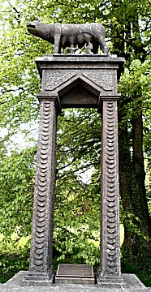  Pow Camp: Listed as an Italian working camp / labour battalion to at least 1945, then a German Working Camp.  The site had a standard layout with a main pow compound, with guards’ huts and offices at the front. Common buildings and facilities at standard type camps included water towers, offices, officer's mess, a canteen, guard rooms, barrack huts, ablution blocks, cell blocks, a camp reception station (medical facility/hospital), a cookhouse, dining rooms, recreation rooms and living huts.  One of the Italian pows, Gaetano Celestra, made a 4m high, concrete and wire statue of Romulus and Remus at Beechbarrow House (NGR ST 570 490).  “Whilst at the camp, Celestra, a mason and builder by trade was employed locally to repair boundary walls. He was granted permission to build the statue with help from fellow POWs during his spare time…. In 1945 the monument was erected alongside the A39, at Pen Hill in recognition of the kind way that the prisoners had been treated. After the War, Celestra settled in the area and continued working as a builder and stonemason…” (Somerset Heritage record). | 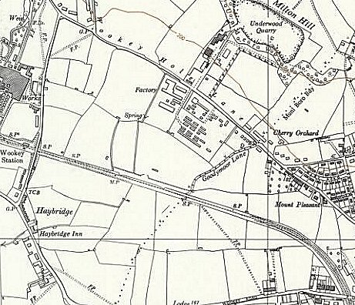
 | Ordnance Survey 1960
Camp commandant c.1947 Lieutenant Colonel A A Crook, D.S.O.
This must be Arthur Ainslie Crook, born 1899. He served a long, distinguished military career with the Northamptonshire Regiment, late Royal Artillery, and was awarded a DSO for his gallant command of 6th (West African) Infantry Brigade during the crossing of the Kaladan River in December 1944. He was also awarded British War and Victory Medals, Africa Star, Burma Star, and the Greek Military Cross, before becoming a Military Knight of Windsor (1963), He died in 1981 - his medals came up for sale in 2014. Some papers relating to his career before becoming a commandant are held by the IWM.

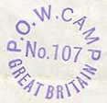
Postal items: POW letter-sheet in German to Germany 1947
< In use 1943, Italian letter-sheet to Italy.
After the camp: The site was taken over by a branch of EMI Electronics. The huts were used for a while, but gradually they were demolished and new buildings replaced them. The factory based here closed down. 2019 residential estate.
Further Information:

