Camp 103 - Moota Camp, Cockermouth, Cumberland

Included in the 1945 ICRC camp list – Labour Camp. 103. Moota Camp, Cockermouth, Cumberland.

1947 Camp list
103(G.W.C.) | Moota Camp, Cockermouth, Cumberland | W. | Priswar, Cockermouth | Aspatria 266 | Aspatria | Major N.Patterson | v/1452/2

Prisoner of War Camps (1939 – 1948) - Project report by Roger J.C. Thomas - English Heritage 2003
OS NGR | Sheet | No. | Name & Location | County | Cond’n | Type 1945 | Comments
NY 160 369 | 89 | 103 | Moota Camp, Moota Hill, Cockermouth | Cumberland | 2 | German Working Camp | STANDARD type. Currently functioning as a hotel

*As there are two books with details about Moota Camp, I provide an outline and some further information here.

Location: On the A595, 7 km NE of Cockermouth.  Before the camp: Farmland  Pow Camp: Built during 1942 by Thomas Armstrong Ltd of Cockermouth with a capacity for up to 1,200 pows. Italian Pows until at least 1944, then a German Working Camp.  The site had a standard layout with a main pow compound, with guards’ huts and offices at the front alongside the road. Common buildings and facilities at standard type camps included water towers, offices, officer's mess, a canteen, guard rooms, barrack huts, ablution blocks, cell blocks, a camp reception station (medical facility/hospital), a cookhouse, dining rooms, recreation rooms and living huts or tents.  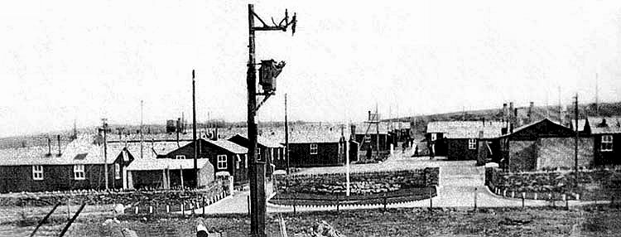 | 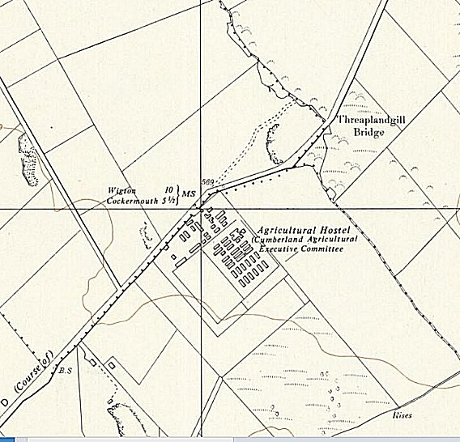
 | Ordnance Survey 1957

The war establishment number and commandant rank (major) indicate that the camp did not exceed 1250 pows.
There were International Red Cross inspections on 14 March 1944 (420 pows) and 28 June 1944.
There are records of an escape attempt by an Italian, and later by two Germans.

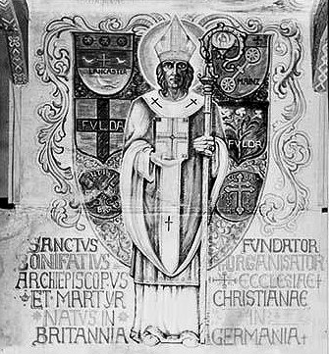 | One hut was used as a chapel. This was highly decorated by an unknown German pow along the side and ceiling panels.  Camp commandant Major G Collins  Camp commandant c.1947 Major N Patterson  After the camp: Became a camp for displaced persons, mainly east Europeans, in 1947. For a while an agricultural hostel. 2019 Garden centre.  Further Information:  National Archives FO 939/274 – Exhibition: 103 Camp, Moota Camp, Cockermouth, Cumberland. Dated 1945-1946. This exhibition was part of activities organised for re-education purposes.  Moota Camp 103, Gloria Edwards, 2005, Little Bird Publications  The War Years – Life in Cockermouth and at Moota POW Camp, Gloria Edwards, 2009, Little Bird Publications
A wall panel depicting St Boniface

