Camp 101 - Glandulas Camp, Newtown, Montgomeryshire (Powys)

Included in the 1945 ICRC camp list – Labour Camp. 101. Glandulas Camp, Newtown, Montgomeryshire

1947 Camp list
101(G.W.C.) | Glandulas Camp, Newtown, Montgomeryshire | W | Priswar, Newtown, Mont. | Newtown 445 | Newtown | Major F.H.Beastall | v/1452/2

Prisoner of War Camps (1939 – 1948) - Project report by Roger J.C. Thomas - English Heritage 2003
OS NGR | Sheet | No. | Name & Location | County | Cond’n | Type 1945 | Comments
 |  | 101 | Glandulas Camp, Newtown | Montgomeryshire (Powys) |  | German Working Camp | Wales

Location: NGR SO 090 901. 2.5 km SW of Newtown.  Before the camp: Farmland. Farm sometimes with spelling Glan-Dulais  Pow Camp: Listed as Italian working camp / labour battalion to at least 1945, then a German working camp.  Map shows a standard type layout with a main pow compound, and guards’ huts and offices at the front alongside the road, (Mochdre Lane).  The camp was raised in Parliament:  “Mr. Peter Freeman asked the Secretary of State for War how many prisoners of war are stationed in the camp near Welshpool; whether separate arrangements have been made for those known to he of Nazi sympathies and those known to be against; and whether all reasonable facilities for recreation and social amenities are provided at this camp for either or both groups.  Mr. Lawson - I assume my hon. Friend is referring to No. 101 Camp, at Newtown. On 15th June, 1946, this camp administered 853 German prisoners of war, of whom 527 were actually accommodated in the camp; only one of them is graded as an anti-Nazi, and 25 are known to have Nazi sympathies but are not "activists"; a large number of these prisoners are not yet classified. Except in the case of ardent Nazis of a type who might cause trouble, it is not now the general practice to segregate prisoners of war. Reasonable amenities have been provided at this camp for all the prisoners.  Mr. Freeman - May I ask whether there were at this camp some 80 or 90 German prisoners from Canada who had been divided into those who had Nazi sympathies and those who had not, and does that classification still continue? If it does not, what is being done to keep Nazi sympathisers separate from the others? | 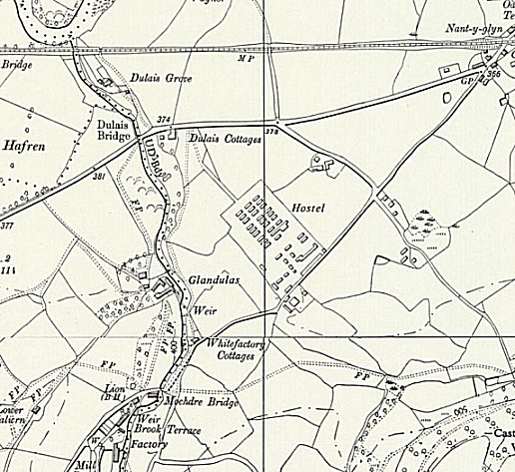
 | Ordnance Survey

Mr. Lawson - I am not aware of the facts as stated by the hon. Gentleman, but I will see that further consideration is given to the matter.

Mr. J. Langford-Holt - Bearing in mind that these prisoners have been in captivity at least 12 months, will the right hon. Gentleman tell us the cause of the delay in categorising them?

Mr. Lawson - Except in the case of ardent Nazis who might cause trouble, it is not now the general practice to segregate prisoners of war. I understand from inquiries I have made that in this camp there are no differences and no troubles of any kind.” (House of Commons, 9 July 1946, Vol 425).

Hostels reported at Llandrillo and Llanrhaeadr-ym-Mochnant
Camp commandant c.1947 Major F H Beastall, (I think he was from the Pioneer Corps).
After the camp: Used for a while as a hostel for agricultural workers. 2019 part residential, part industrial.
Further Information:
IWM have a copy of the camp newspaper ‘Glandulas Post’ dated February May 1947. Catalogue number LBY E.J. 360.

