Camp 100 - St Martins Camp, St Martins, nr Oswestry, Shropshire

Included in the 1945 ICRC camp list – Labour Camp. 100. St.Martins Camp, Oswestry, Shropshire.

1947 Camp list
100(G.W.C.) | St.Martins Camp, St.Martins, Oswestry, Shropshire | W. | Priswar, St.Martins, Shropshire | Chirk 2176 | Gobowen | Lt.Col.W.H.Dumain | v/1453/2

Prisoner of War Camps (1939 – 1948) - Project report by Roger J.C. Thomas - English Heritage 2003
OS NGR | Sheet | No. | Name & Location | County | Cond’n | Type 1945 | Comments
SJ 311 363 | 126 | 100 | St Martins (St Martin's) Camp, St Martins, Gobowen | Shropshire | 1 | German Working Camp | STANDARD type. Light industrial estate

Location: About 1.5 km SWW of St Martins; 7 km N of Oswestry  Before the camp: Farmland  Pow Camp: Built by Italian pows who lived in tents until the construction was completed. Opened in 1943. Listed as Italian working camp / labour battalion for up to 600 pows to at least 1945, then a German working camp and increased size.  The site had a standard layout with a main pow compound, and with guards’ huts and offices at the front facing the road. Common buildings and facilities at standard type camps included water towers, offices, officer's mess, a canteen, guard rooms, barrack huts, ablution blocks, cell blocks, a camp reception station (medical facility/hospital), a cookhouse, dining rooms, recreation rooms and living huts. One hut was converted for use as a chapel.  The huts were mainly Standard type made from prefabricated concrete sections.  ‘On February 18th 1945, a number of German PoWs escaped and one managed to get onto Rednal Airfield, a big Spitfire training base. He fell asleep in a Spitfire cockpit and was discovered in the morning by a WAAF flight mechanic called Margery Lamb. "One of our jobs was to empty the planes of petrol every night. In the morning the first thing we did was to fill them with petrol again. I struggled up this icy wing to open the cockpit and there he was, a very beautiful blond German pilot, who was asleep. I let out a bloodcurdling scream that brought everybody running to the spot and also woke up the fugitive. While they awaited the arrival of the Military Police, the Group Captain invited the German into the crew room for a drink of hot cocoa. He conveyed to the Group Captain he would not go until he found me. By this time, I was hiding at the back of the crowd. He found me and beckoned me. He said, 'You cocoa with me'. So, I found myself drinking cocoa with a German escapee. As I left, he clicked his heels and bowed. He gave himself up without a fight and on being searched was found | 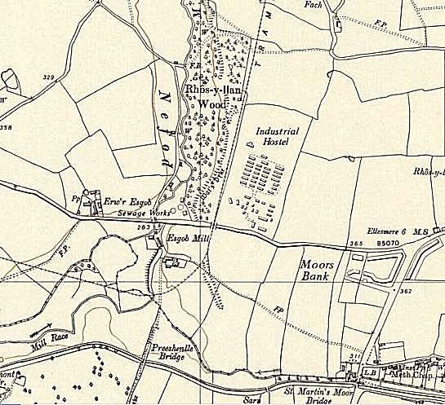
 | Ordnance Survey 1954
to have in his possession a half pound of black pepper in a tin and a knife handle sharpened to a razor's edge. The prisoner was returned to the POW camp. Later in the day it was reported that all the escaped prisoners had been recaptured." ‘ (Shropshire HER).
Also listed as a satellite camp for Mile House Camp 8.

Camp commandant c.1947 Lieutenant Colonel W H Dumain, from the Royal Artillery.

After the camp: Used for a short time as a European Voluntary Workers Camp. 2019 industrial estate.

Further Information:

Field survey report: Hankinson R. 2016. Bank Top Industrial Estate, St Martin's, Shropshire: building recording. CPAT Rep. 1440.

