Camp 55 - Shalstone Camp, Shalstone, Buckinghamshire

Included in the 1945 ICRC Camp list – Labour Camp. 55. Shalstone Camp, Shalstone, Buckingham

1947 Camp List
55(G.W.C.) | Shalstone Camp, Shalstone, Buckingham | E. | Priswar, Shalstone, Buckingham | Buckingham 3162 | Finmere | Lt.Col.C.P.Moore M.C. | v/1453/2

Prisoner of War Camps (1939 – 1948) - Project report by Roger J.C. Thomas - English Heritage 2003
OS NGR | Sheet | No. | Name & Location | County | Cond’n | Type 1945 | Comments
SP 657 356 | 152 | 55 | Shalstone Camp, Shalstone | Buckinghamshire | 3 | German Working Camp | STANDARD type.

Location: About 4km NW of Buckingham. The village of Shalstone is about 1.5km NW of the camp.  Before the camp: Farmland  Pow Camp: Opened 1942. Italian pows to 1945, then German pows. The camp was built by Italian pows and the Pioneer Corps. Mainly Nissen huts with concrete buildings for amenities; cookhouse, ablutions, showers, etc..  Italian pows working on farms were increasingly billeted there. Reported that some worked in the brickworks at Bletchley. One local memory was of pows making baskets from willows growing along the local brooks – and another who made very good shoes.  One of the pows at Shalstone up to January 1946, was Hauptman Dr Georg Hesterberg who had been involved in the murder of British pows in Poitiers, France. (Further details see ‘SAS Operation Bulbasket. Behind the Lines in Occupied France’, Paul McCue, 1996, Leo Cooper publisher).  Camp commandant Lieutenant Colonel Charles P Moore M.C. (I think he was with the King’s Regiment).  After the camp: The site was used for displaced people with many from Yugoslavia. Later mixed use including boarding kennels.  Further information:  National Archives FO 939/137 55 Working Camp, Shalstone Camp, Buckinghamshire. Dated 1946-1947. | 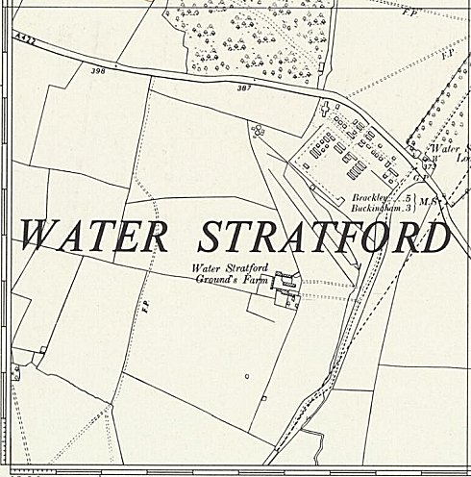
 | Ordnance Survey 1958

Sub-camp at Haversham  Wooden huts – one pow memory states about 140 pows. Pows working on local farms and for the Ministry of Agriculture.  A newspaper article reports how security relaxed two years after the war: “P.O.W. were now allowed to ride on buses and to spend at local shops. On Saturday last many of the German P.O.W. stationed at Haversham Camp visited Wolverton and went to the ‘pictures’ and spent money in shops, and looked in at two dances. This added freedom to the relaxation recently announced Government restrictions.  Haversham is a White Camp and there are 141 P.O.W. housed there. A White Camp indicates that all the men there are anti-Nazi, and about a third of them speak English. They have between 4/- and 4/6 a week to spend outside the camp, and the maximum allowed in their possession is 30/- ordinary rank and £3 officers.  A Wolverton Express reporter spoke to a German interpreter at the Camp and said the men were pleased with the additional freedom. But they must be back in by 10pm or lighting-up time, whichever is earlier and they must remain within bounds. The only public resorts that the P.O.W. were not allowed to enter were those where intoxicants were sold. Cigarettes and newspapers were the most sought after items’. (Wolverton Express, 12 July 1947) | 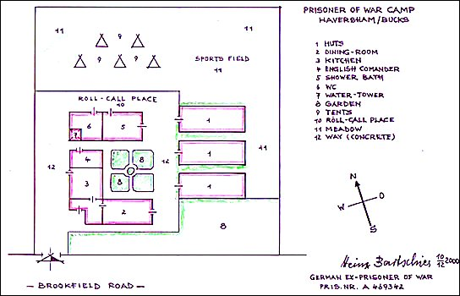
 | Plan of camp by German ex-pow – Heinz Bartschies
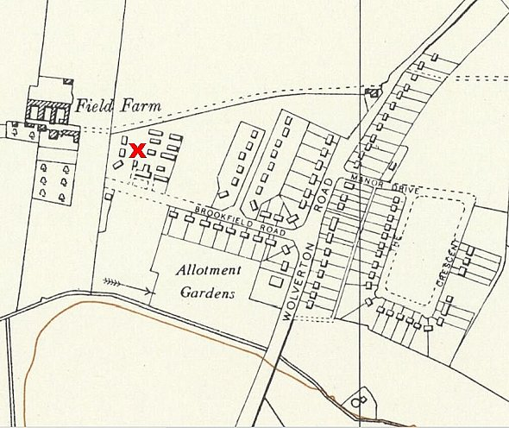
The pows built wooden toys to sell, and in the camp a model castle. A 3-foot concrete star was at the entrance to the camp.

Details from ‘Haversham Estate And the Parish I Grew Up In’ by David C Brightman, April 2000 - http://www.mkheritage.co.uk/hav/docs/camp/camp.html

< NGR SP 818 427, Ordnance Survey 1957. I am not sure if the site marked at the end of Brookfield Road shows the camp buildings or the new build for the estate.

Sub-camp at Sherington  As part of the national scheme to increase agricultural production, War Agricultural Executive Committees (WAR-AG) were set up working with county councils. It was Newport Pagnel District Council that directed this camp to be established in 1943. Held between 50 to 100 pows.  NGR SP 894 464 - Ordnance Survey 1958 > | 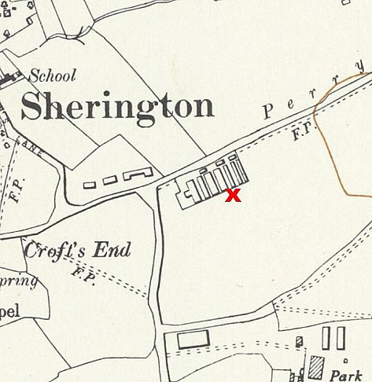
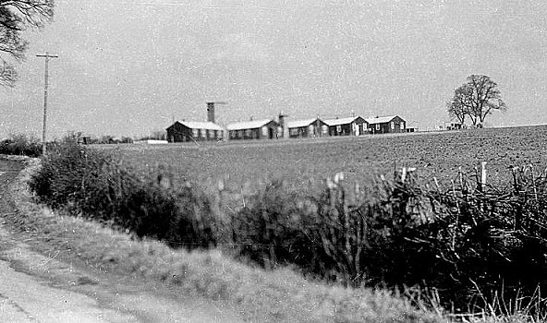
It held Italian co-operator pows to about 1945/46, then, as they were placed in billets, it held low risk German pows. Security was minimal.

Staff Sergeant Wilf Rollinson was in charge. He settled locally, married the farmer’s daughter and became a WAR-AG executive.

The site is now a small residential estate.

Sherington Historical Society have an archive file on the camp.

